YEAR 7
End of Year Assessment

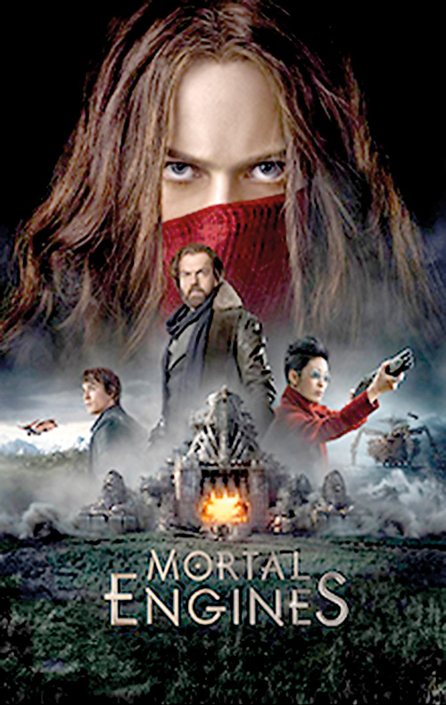

Extract from Mortal Engines by Philip Reeve
This extract is taken from Chapter 3 of a novel called Mortal Engines by Philip Reeve.
The story is set in the future where the earth’s natural resources are limited. Cities have been built on platforms that can move from one place to another in search of necessary resources. Larger cities chase and attack smaller cities taking everything that is useful.
The City of London has started to move again in search of smaller cities to steal from.
In the extract Tom, a young apprentice is chasing a girl who attempted to kill Mr Valentine, a hero to many people in the city, including Tom.

He ducked past the dangling head-scarf and ran on, gasping for breath, fumbling his collar open. Down a giddy spiral of iron stairs and out on to the floor of the Digestion Yards, flashing through the shadows of conveyor belts and huge spherical gas-tanks. A gang of convict labourers looked up in amazement as the girl raced by. “Stop her!” yelled Tom. They just stood gawping as he passed, but when he looked back he saw that one of the Apprentice Engineers who had been supervising them had broken off his work to join the chase. Tom immediately regretted shouting out. He wasn’t going to give up his victory to some stupid Engineer! He put on an extra spurt of speed, so that he should be the one who caught her.
Ahead, the way was barred by a circular hole in the deckplate, ringed by rusty handrails – a waste chute, scorched and blackened where clinker from the furnaces had been tipped down. The girl broke her pace for a moment, wondering which way to turn. When she went on, Tom had narrowed her lead. His outstretched fingers grabbed her pack; the strap broke and she stopped and spun to face him, lit by the red glare of the smelters.
She was no older than Tom, and she was hideous. A terrible scar ran down her face from forehead to jaw, making it look like a portrait that had been furiously crossed out. Her mouth was wrenched sideways in a permanent sneer, her nose was a smashed stump and her single eye stared at him out of the wreckage, as grey and chill as a winter sea.
“Why didn’t you let me kill him?” she hissed.
He was so shocked that he couldn’t move or speak, could only stand there as the girl reached down for her fallen pack and turned to run on. But behind him police whistles were blowing, and crossbow darts came sparking against the metal deck-plates and the overhead ducts. The girl dropped the pack and fell sideways, gasping a filthy curse. Tom hadn’t even imagined that girls knew such words. “Don’t shoot!” he yelled, waving towards the policemen. They were lumbering down the spiral stair beyond the gas-tanks, shooting as they came, as if they didn’t much care about that Tom was in the way. “Don’t shoot!”
The girl scrambled up, and saw that a crossbow-dart had gone through her leg just above the knee. She clutched at it, blood welling out between her fingers. Her breath came in sobs as she backed up against the handrail, lifting herself awkwardly over it. Behind her, the waste-chute gaped like an open mouth.
“No!” screamed Tom, seeing what she meant to do. He didn’t feel like a hero any more – he just felt sorry for this poor, hideous girl, and guilty at being the one who had trapped her here. He held out his hand to her, willing her not to jump. “I couldn’t let you hurt Mr Valentine!” he said, shouting to make her hear him above the din of the Gut. “He’s a good man, a kind, brave, wonderful…”
The girl lunged forward, shoving her awful noseless face towards him. “Look at me!” she said, her voice all twisted by her twisted mouth. “Look what your brave, kind Valentine did to me!”
“What do you mean?”
“Ask him!” she screamed. “Ask him what he did to Hester Shaw!”
The police were closer now; Tom could feel their footsteps drumming on the deck. The girl glanced past him, then heaved her wounded leg over the handrail, crying out in the pain. “No!” pleaded Tom again, but too late. Her ragged greatcoat snapped and fluttered and she was gone. He flung himself forward and peered down the shadowed chute. A cool blast of air came up at him, mingled with the smell of mud and crushed vegetation; the smell of the speeding earth beneath the city.
“No!”
She had jumped! She had jumped right out of the city to her death! Hester Shaw. He would have to remember that name, and say a prayer for her to one of London’s many gods.
Shapes loomed out of the drifting smoke. The policemen were advancing cautiously, like watchful crabs, and Valentine was with them, running ahead. In the shadows under a gas-tank Tom saw the young Engineer looking on, shocked. Tom tried to smile at him, but his face fell frozen, and the next moment another thick swag of smoke had folded over him, blotting out everything.
“Tom! Are you all right?” Valentine ran up, barely winded by the chase. “Where is she? Where is the girl?”
“Dead,” Tom said lamely.
Valentine stood beside him at the handrail and peered over. The shadows of the drifting smoke moved over his face like cobwebs. There was a strange light in his eyes, and his face was tight and white and frightened. “Did you see her, Tom? Did she have a scar?”
“Yes,” said Tom, wondering how Valentine could know that. “It was horrible! Her eye was gone, and her nose…”
Then he remembered the terrible thing the girl had told him. “And she said …” But he wasn’t sure if he should tell Mr Valentine what she had said – it was a lie, insane.
“She said her name was Hester Shaw.”
“Great Quirke!” hissed Valentine, and Tom flinched backwards, wishing he had never mentioned it. But when he looked up again Valentine was smiling kindly at him, his eyes full of sorrow. “Don’t worry Tom,” he said. “I’m sorry…”
Tom felt a big, gentle hand on his shoulder and then – he was never sure quite how it happened – a twist, a shove, and he was pitching over the handrail and falling, just as Hester Shaw had fallen, flailing wildly for a hold on the smooth metal at the brim of the waste chute. He pushed me! he thought, and it was more amazement that he felt than fear as the black throat swallowed him down into the dark.

Question 1:
Re-read the opening paragraph again and select 4 techniques (eg verbs) or words used to create the speed and the energy of the chase and explain how they create speed or energy.
He ducked past the dangling head-scarf and ran on, gasping for breath, fumbling his collar open. Down a giddy spiral of iron stairs and out on to the floor of the Digestion Yards, flashing through the shadows of conveyor belts and huge spherical gas-tanks. A gang of convict labourers looked up in amazement as the girl raced by. “Stop her!” yelled Tom. They just stood gawping as he passed, but when he looked back he saw that one of the Apprentice Engineers who had been supervising them had broken off his work to join the chase. Tom immediately regretted shouting out. He wasn’t going to give up his victory to some stupid Engineer! He put on an extra spurt of speed, so that he should be the one who caught her.

Technique / word | Explanation

[8 marks]

Question 2. How has the write used language to convey how shocking Hester’s scarred face is in the section below?
She was no older than Tom, and she was hideous. A terrible scar ran down her face from forehead to jaw, making it look like a portrait that had been furiously crossed out. Her mouth was wrenched sideways in a permanent sneer, her nose was a smashed stump and her single eye stared at him out of the wreckage, as grey and chill as a winter sea.

________________________________________________________________________________________________________________________________________________________________________________________________________________________________________________________________________________________________________________________________________________________________________________________________________________________________________________________________________________________________________________________________________________________________________________________________________________________________________________________________________________________________________________________________________________________________________

[4 marks]
Question 3. Thinking about the whole of the extract.
How does the Writer make the reader feel about Mr Valentine in the extract?

You could think about:
- What Tom thinks or feels about Mr Valentine
- What Hester thinks or feels about Mr Valentine
- Mr Valentine’s actions
________________________________________________________________________________________________________________________________________________________________________________________________________________________________________________________________________________________________________________________________________________________________________________________________________________________________________________________________________________________________________________________________________________________________________________________________________________________________________________________________________________________________________________________________________________________________________

____________________________________________________________________________________________________________________________________________________________________________________________________________________________________________________________________________________________________________________________________________________________________________________________________________________________________________________________________________________________________________________________________________________________________________________________________________________________________________________________________________________________________________________________________________________________________________________________________________________________________________________________________________________________________________________________________________________________________________________________________________________________________________________________________________________________________________________________________________________________

[8 marks]
Section B: Writing Task
Task: You are to write the next part of the story.
Tom and Hester survive the fall down the waste chute and end up on the ground. Read the opening section of chapter 4 and continue the story.
Mud! He sat up, gasping. He wasn’t in the Third Class dormitory at all. He was lying on a great hump-backed mound of mud, on the edge of a deep trench, and in the thin, pearl-grey light of dawn he could see the girl with the ruined face sitting nearby. His horrible dream of sliding down that fire-blackened chute had been true: he had fallen out of London, and he was alone with Hester Shaw on the bare earth!

Aim to write 3 – 5 paragraphs

Plan your writing:
Tools for engagement and cohesion  Connectives  Time: (when) meanwhile, eventually, soon after, later, suddenly, since, moments later, years before, now  Place: (where) everywhere, somewhere, nearby here  Cause (how) whether, even though, probably, unless, eventually, even, despite | Vocabulary I will use – similar to the extract  Punctuation (tick off when included)  ; : … “ “  Punctuation you are expected to use correctly  , . ‘ ! ?
Tools/methods/devices I could include:  Powerful verbs, exaggeration, personification, emotive language, metaphors / simile, repetition, 5 senses (show, don’t tell), emotive language, repetition. | Sentence openers  Very short sentence  -ly (adverbs) -ed (verb)  -ing (verb) Preposition (in, over, beside) Clausal (when, while…)  Transitional (above all, moreover…)  Sentence types  Simple Compound Complex Embedded clause

____________________________________________________________________________________________________________________________________________________________________________________________________________________________________________________________________________________________________________________________________________________________________________________________________________________________________________________________________________________________________________________________________________________________________________________________________________________________________________________________________________________________________________________________________________________________________________________________________________________________________________________________________________________________________________________________________________________________________________________________________________________________________________________________________________________________________________________________________________________________

____________________________________________________________________________________________________________________________________________________________________________________________________________________________________________________________________________________________________________________________________________________________________________________________________________________________________________________________________________________________________________________________________________________________________________________________________________________________________________________________________________________________________________________________________________________________________________________________________________________________________________________________________________________________________________________________________________________________________________________________________________________________________________________________________________________________________________________________________________________________

