A level Biology Bridging task Summer 2021
NAME: ………………………………………..

A-level Biology is a big step up from GCSE. To help you succeed on this challenging A level course it is vital that you are organised and have an excellent understanding of the concepts you covered at GCSE and will study in greater depth over the first year of A-level Biology. You will need to complete all tasks outlined in time for enrolment in September.
Year 12 Biology bridging task |  | Ex | Gd | Sf
Task 1:  Organisation | A file, with dividers or clear sections for Year 1 modules and lined paper
 | Stationary
 | Calculator
Task 2: Recapping GCSE knowledge using PHYSICS & MATHS TUTOR WEBSITE | Complete this bridging task to cover the following key concepts:
Part 1: Maths for Biologists:
Ensure you read through the information, revise if needed and then complete activities 1-4.
Part 2: Practical work for the A level Biologist:
Read through each section and complete all activities related to practical work and data analysis
 | Part 3: Some key concepts to cover as an introduction to some of the subject knowledge covered in A level Biology
Task 3: Wider reading | Read a biology based book and write a synopsis. Complete an A3 poster, read through some biology in the news
In order to support completion of this bridging task and transition to A level Biology the following books may be of use.
Suitable websites include:
http://www.bbc.co.uk/schools/gcsebitesize/science/add_aqa/ (scroll down to the Biology section)

https://www.physicsandmathstutor.com/biology-revision/gcse-aqa/

https://www.rsb.org.uk/students

Any questions? Email
m.clinton-lees@bishopullathorne.co.uk

Part 1:Maths for Biologists

This section aims to introduce you to (or reinforce) some of the common maths used in Biology.

Standard Prefixes
Prefixes are used to modify units. Prefixes that are commonly used are listed below - you are most likely to be asked to convert between the ones highlighted:

Prefix Symbol Multiplier Example
mega M x10⁶ (or x 1,000,000) Mb (megabyte)

kilo K x10³ (or x 1,000) kJ (kiloJoule)

no prefix - x10° (or x 1) N (Newton)

deci d x10⁻¹ (or x 0.1) dm³ (cubic decimetre or litre)

centi c x10⁻² (or x 0.01) cm (centimetre)

milli m x10⁻³ (or x 0.001) mg (milligram)

micro µ x10 ⁻⁶ (or x 0.000001) µm (micrometre)

nano n x 10⁻⁹ (or x 0.000000001) nm (nanometre)

pico p x10⁻¹² ( or x 0.000000000001) pg (picogram)

SI Units

These units are used for most scientific purposes and have been defined by experiment, so the size of a metre in the UK is the same as a metre in China.

Base quantity |  |  | Base unit
Name | Typical symbol |  | Name | Symbol
Time | t |  | second | s
Length | l, x, r, etc. |  | metre | m
Mass | M |  | kilogram | kg
electric current | I, i |  | ampere | A
thermodynamic temperature | T |  | kelvin | K
amount of substance | N |  | mole | mol
luminous intensity | I_{v} |  | candela | cd

All other units can be derived from the SI base units. For example, area is measured in square metres (written as m²) and speed is a measure of metres per second (written as ms⁻¹)

Activity 1:
Which SI unit and prefix would you use for the following quantities?

1) The time between heartbeats?

2) The length of a leaf

3) The distance that a migratory bird travelled each year

4) The width of a cheek cell

5) The mass of a rabbit

6) The mass of iron in the body

7) The volume of the trunk of a large tree.

Standard Form
Numbers with many zeros can be difficult to follow, so we express these in standard form – it acts as a kind of numerical abbreviation.

Example:
The herpes virus has 156,000 bases in its DNA.
So how do we express the number 156,000 in standard form?

- Find the decimal point: 156,000.0
- Move the decimal point to give a number between 1 and 10: 1.56000
- Multiply the number by 10 raised to the power x
- x is the number of jumps that you made to the left
- Answer = 1.56 ×10⁵
Sometimes the decimal point may move the other way.

Example:
The blood protein IgE is connected with allergic reactions. Its concentration in the blood is about 0.000012 grams per 100cm³:

- Find the decimal point and move it to give a number between 1 and 10.
- This time it goes to the right: 000001.2
- Multiply the number by 10 raised the power x
- x is the number of jumps you made
- This time the index will be negative.
- In standard form, the concentration is 1.2 ×10^{–5} grams per 100cm³.

Activity 2: Standard Form Questions

1) Write down the following measures in standard form:

(a) 750 g

(b) 500 ml

(c) 0.275 J

(d) 0.0095 N

(e) 10,000 KJ

(f) 0.0033 mm

Ratios, Fractions and Percentages
A ratio is a way of comparing the magnitudes of two (or more) quantities. You can only give a ratio when the units of each quantity are the same, so when working with a ratio involving different units, always change them to the same unit. The ratio itself does not have any units. For example, the ratio of 125 g to 2 kg must be changed to 2000 g, so that it can be given as 125:2000.

- Divide both sides by 5, giving 1:16, the simplest form of the ratio.

Ratios can be used to calculate other quantities,
You can take a ratio in its simplest form and express the amount of each part of the ratio as a fraction. Each will have the same common
denominator.

Example:

A field is sown with two different types of seed in the ratio 3:2. Seed x makes up 3/5 of the contents of the field, and seed y makes up 2/5 of the contents of the field. The common denominator (5) comes from adding the numbers in the ratio (3+2)

Ratios can also be expressed as percentages. In the above example, seed x takes up 60% (3/5×100) of the field, and seed y 40%.

We can write a ratio as a fraction by scaling the ratio so that it is divided by the total number of parts.
Example: To make mortar, we need 1 part cement, and 2 parts sand. The total number of parts for one batch of mortar is $1+2=3$. Thus the ratio for creating mortar is 1:2 which can also now be expressed as $\frac{1}{3}:\frac{2}{3}$
From this form, it is easy to see how much of the total mixture is sand ($\frac{2}{3})$ and how much is concrete ($\frac{1}{3}$).

Activity 3: Ratio calculations
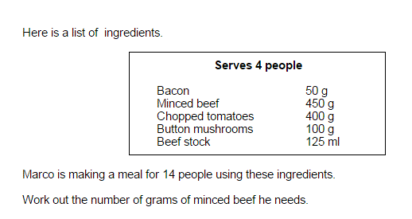
1)

Answer to Qu 1

Answer to Qu 2

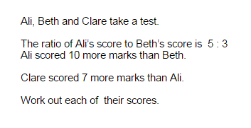
2)

3) 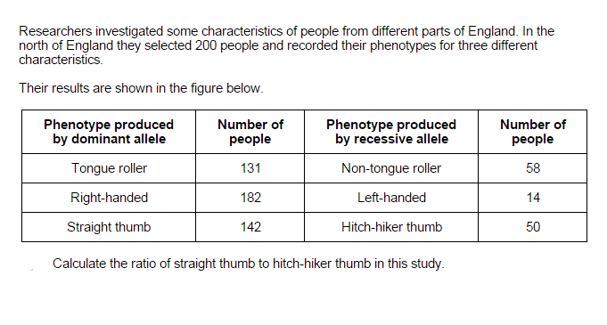

Percentage Change
Method
% change = final value - original value x 100
original value

Activity 4: Percentage Change Questions:

1) A piece of potato, weighing 3g increases in mass to 7g when placed in a sucrose solution. What is its percentage change?

2) Another piece of potato increases from 4g to 5g - what is its percentage increase?

3) Another piece of potato loses mass as it changes from 6 g to 5.5g, what is its percentage change?

Scaling
REMEMBER:
Actual Size = Image size
Magnification

so Magnification = Image size
Actual size

(AND Image size = Actual size x Magnification)
The triangle below can be useful – cover up the required value

E.g.
- To calculate I = M x A
- To calculate M = I/A
- To calculate A = I/M

To convert mm to μm x1000 μm to mm divide by 1000

Activity 5: Microscope Questions
1) An image with a magnification of x50 shows an ant’s head to be 40mm long. Calculate the actual length in μm.

2) A photograph shows the width of a human egg to be 700mm. Its actual size is 0.1 mm. What is the magnification?

3) A cell measures 20mm - what is the image's magnification if the cell is actually 500μm in length?

Mean Averages
In biology practical work, we often quote an ‘average value’. The correct term for this type of average value is the mean. The arithmetic mean is given by the equation:
x = Σx
n

Σx means the sum of all the x values.
The mean of 8, 5, 3, 8, 7, 5, 7 = 8 + 5 + 3 + 8 + 7 + 5 + 7 = 7
7

Question
1) Four students weigh 70kg, 65kg, 80kg and 55kg - what is their mean body mass?

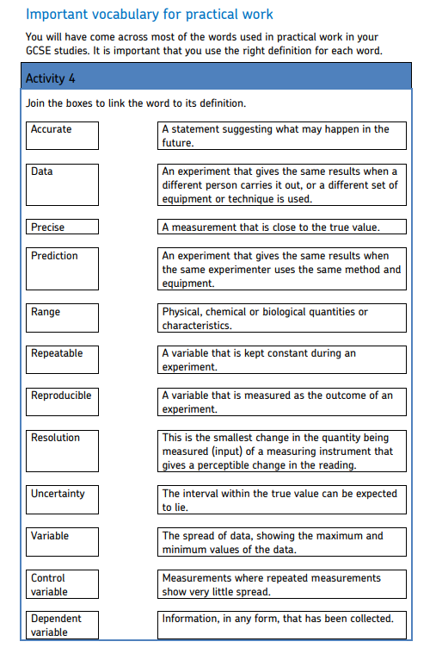
Part 2 - Practical work for the A level Biologist

Read through and match each word to its correct A level Biology definition.

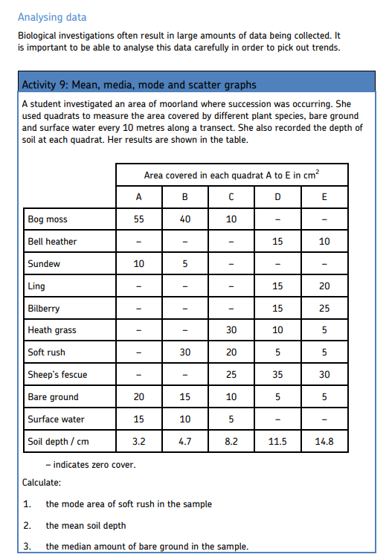

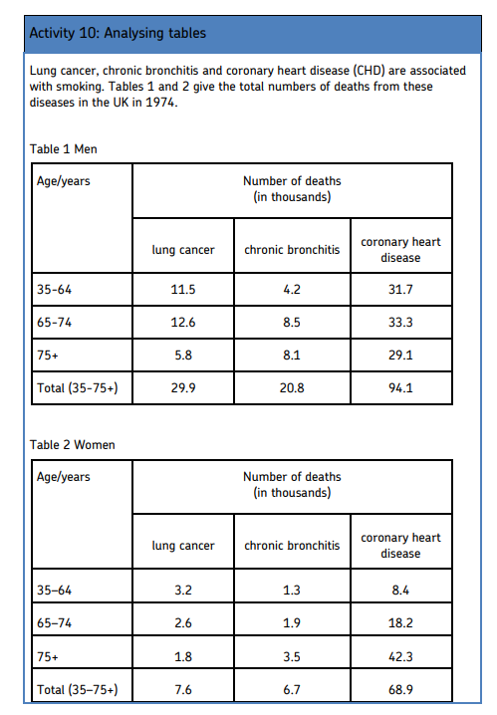

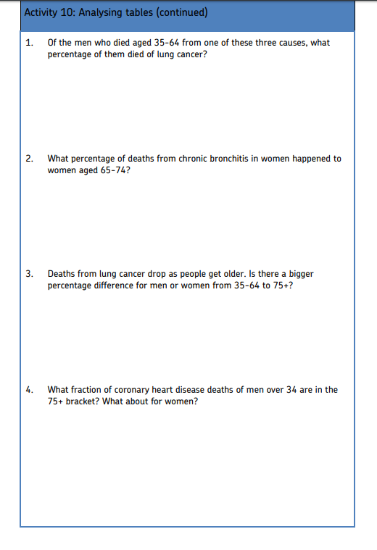

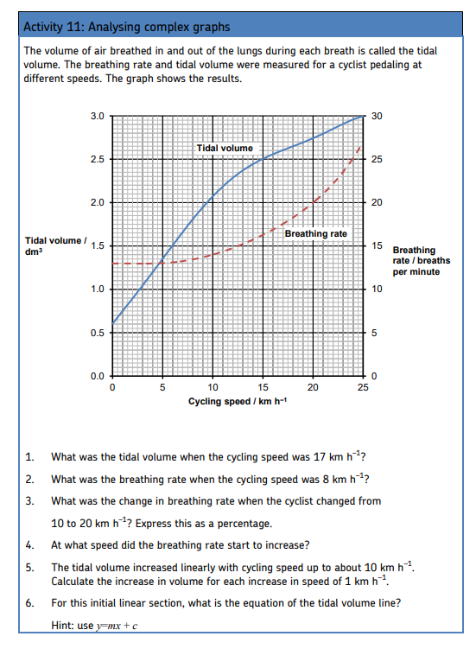

Part 3: Some key concepts for A level Biology

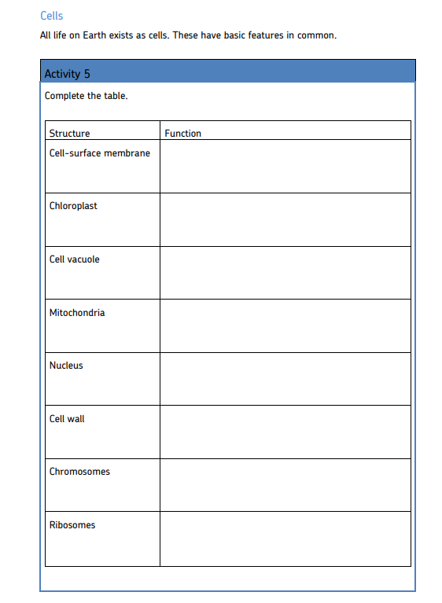

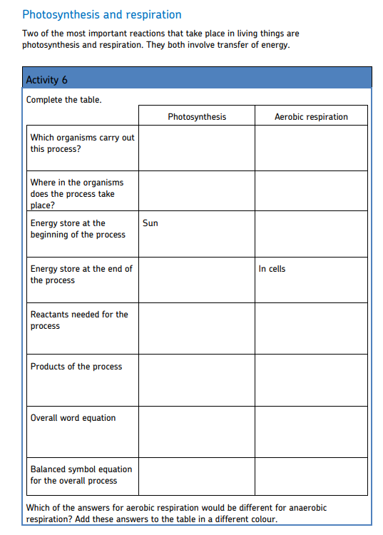

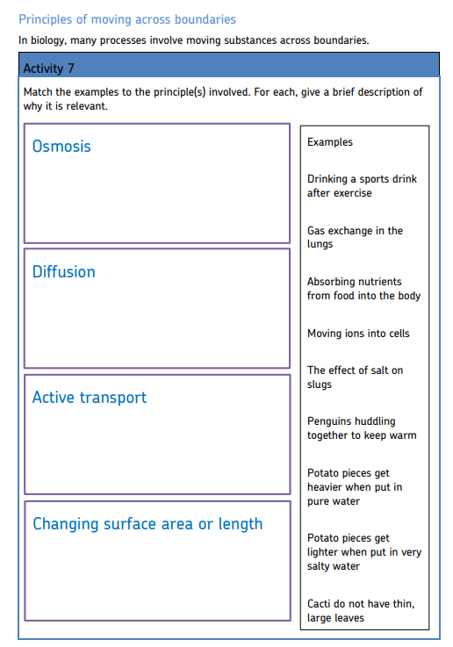

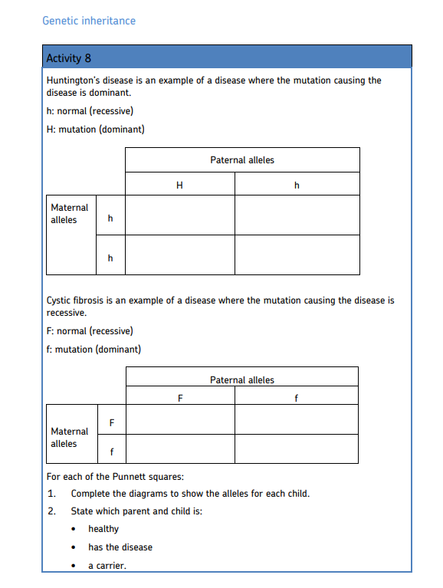

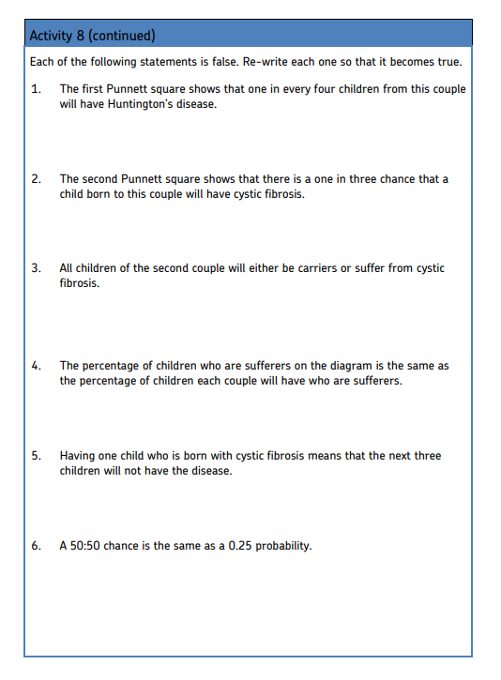

Task 3: wider reading in Biology:

1) Read a biology based science book and write a short (200 words) evaluation of the book.

A few suggestions:
• Adventures in Human Being’ by Gavin Francis
• The Immortal Life of Henrietta Lacks by Rebecca Skloot
• The Incredible Unlikeliness of Being: Evolution and the Making of Us by Alice Roberts

2) In preparation for your first lesson in September, you need to complete an A3 poster on one of the following topics:
• The importance of saprobionts
• Outline evidence for The Endosymbiotic Theory
• Our impact on ocean life
• How modern farming methods can support biodiversity
• What can a household do to help limit their impact on the environment

3) Comment on an example of use of scientific data in the news.
It needs to be: Visually attractive Interesting Clear concise information Include a list of the resources that you used to produce your report.

