This extract is from a story by Angie Thomas (author of ‘The Hate U Give’). In this novel, ‘On The Come Up’, sixteen-year-old Brianna moves between two worlds: the poor black neighbourhood where she lives and the high achieving school she attends. The uneasy balance between these worlds is shattered when Brianna is unfairly treated by the guards at her school and her mum, Jay, is called into school by Dr Rhodes (the Principal). Brianna, a very talented young rap artist, had recently expressed her feelings about how the world treated her during rap battle after which her song went viral.

My backpack sits on top of her desk. It's unzipped, revealing every pack of candy I had.
Dr. Rhodes points at the two chairs in front of her. "Please, have a seat." We do. "Are you going to tell me why my daughter was handcuffed?" Jay asks.
"There was an incident—”
"Obviously.”
"I will be the first to admit that the guards used excessive force. They put Brianna on the floor."
"Threw," I mumble. "They threw me on the floor."
Jay's eyes widen. "Excuse me?"
"We've had issues with students bringing illegal drugs—"
"That doesn't explain why they manhandled my child!" says Jay.
"Brianna was not cooperative at first."
"It still doesn't explain it!" Jay says.
Dr. Rhodes takes a deep breath. "It will not happen again, Mrs. Jackson. I assure you that there will be an investigation and disciplinary action will take place if the administration sees fit. However, Brianna may have to face disciplinary action as well." She turns to me. "Brianna, have you been selling candy on campus?"
I fold my arms. I'm not answering that shit. And let her turn this around on me? Hell no.
"Answer her," Jay tells me.
"It's only candy," I mumble.
"Maybe so," says Dr. Rhodes, "but it's against school policy to sell contraband on campus."
Contraband? "The only reason y'all found out about it is because Long and Tate like to go after the black and Latinx kids!"
"Brianna," Jay says. It's not a warning. It's an "I got this." She turns to Rhodes. "Since when is candy contraband? Why did they come after my daughter in the first place?"
"The security guards have the right to conduct random searches. I can assure you that Brianna was not 'targeted."'
"Bullshit!" I don't even bite my tongue. "They always harass us."
"Mrs. Jackson, Brianna is frequently aggressive—"
Aggressive. One word, three syllables. Rhymes with excessive.
I'm so excessive,
that I'm aggressive.
"Aggressive" is used to describe me a lot. It's supposed to mean threatening, but I've never threatened anybody. I just say stuff that my teachers don't like. There was the time in history class during Black History Month. I asked Mr. Kincaid why we don't ever talk about black people before slavery. His pale cheeks reddened.
"Because we're following a lesson plan, Brianna," he said.
"Yeah, but don't you come up with the lesson plans?" I asked.
"I will not tolerate outbursts in class."
"I'm just saying, don't act like black people didn't exist before—"
He told me to go to the office. Wrote me up as being "aggressive."
We go into the hallway just as the bell for second period rings. Classroom doors open, and it seems like everybody and their momma pour into the halls. I get second glances I've never gotten before, and stares and whispers. I'm no longer invisible, but now I wish I was.
I'm quiet on the ride home. Hoodlum. One word, two syllables. Can be made to rhyme with a lot of things. Synonyms: thug, delinquent, hooligan, lowlife, gangster, and, according to Long, Brianna.
Can’t no good come,
From this hoodlum.
I stare at what's left of the Garden. We're on Clover Street, which used to be one of the busiest streets in Garden Heights, but ever since the riots, there's a bunch of charred nibble and boarded-up buildings. The Mega Dollar Store was one of the first to get hit. Cellular Express got looted first and then burned down. Shop 'n Save burned down to the frame, and now we have to go to the Walmart on the edge of the Garden or the little store over on the west if we wanna get groceries.

I'm a hoodlum from a bunch of nothing.

''Doubt they'll ever fix this mess," Jay says. "It's like they want us to remember what happens when we step out of line." She glances over at me. "You okay, Bri?"
According to my granddaddy, Jacksons don't cry—we suck it up and deal with it. Doesn't matter how much my eyes burn. "I didn't do anything wrong."
"No, you didn't," Jay says. "You had every right to keep your backpack. But Bri . . . Promise me, if that ever happens again, you'll do what they tell you to do."
"Bad things can happen, baby. People like that sometimes abuse their power."
"So I don't have any power?"
"You have more than you know. But in moments like that, I— She swallows. "I need you to act as if you don't have any. Once you're safely out of the situation, then we'll handle it. But I need you safely out of the situation.

This is like that talk she gave me about the cops. Do whatever they tell you to do, she said. Don't make them think you're a threat. Basically, weaken myself and take whatever's thrown at me so I can survive that moment.
I'm starting to think it doesn't matter what I do. I'll still be whatever people think I am. "They're always on my case at that school."
"I know," Jay says. "And it's not fair. But you only have to get through two more years, baby. All these incidents we can't risk you getting expelled, Bri. If that means keeping your mouth shut, I need you to do it."
"I can't speak up for myself?"
"You pick your battles," she says. "Not everything deserves a comment or an eye roll or an attitude—"
"I'm not the only one who does that stuff!"
"No, but girls like you are the only ones getting hits on their permanent record!"
The car goes quiet.
Jay sighs out of her nose. "Sometimes the rules are different for black folks, baby," she says. "Hell, sometimes they're playing checkers while we're in a complicated-ass chess game. It's an awful fact of life, but it's a fact. Midtown is unfortunately one of those places where you not only gotta play chess, but you gotta play it by a different set of rules."
I hate this shit. "I don't wanna go back there."
"I understand, but we don't have any other options."
"Why can't I go to Garden High?"
"Because your daddy and I swore that you and Trey would never step foot in that school," she says. "You think the guards are bad at Midtown? They have actual cops at Garden High, Bri. The damn school is treated like a prison. They don't set anybody up to succeed. Say what you want about Midtown, but you've got a better chance there."
"A better chance at what? Getting tossed around like a rag doll?"
"A better chance at making it!" She's louder than me. She takes a deep breath. "You're gonna face a whole lot of Longs and Tates in your life, baby. More than I'd like. But you never let their actions determine what you do. The moment you do, you've given them the power. You hear me?"
Yeah, but does she hear me? Neither of us speaks for the longest.
"I wish . . . I wish I could give you more options, baby. I do. We don't have any. Especially right now."

Your Task:
You may refer to the whole extract in response to the following question. A reader said, ‘This part of the story, demonstrates how Brianna doesn’t really stand a chance, the odds are stacked against her.’
To what extent do you agree? (20 Marks)

In your response, you could:
• consider the reasons why Brianna found herself in trouble at school.
• evaluate how the writer shows Brianna’s reaction to her situation.
• support your response with references to the text.

Writing Task:
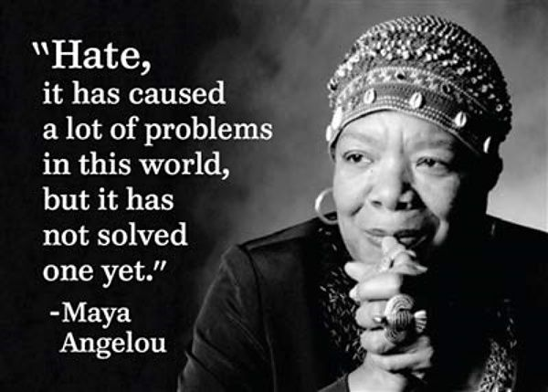
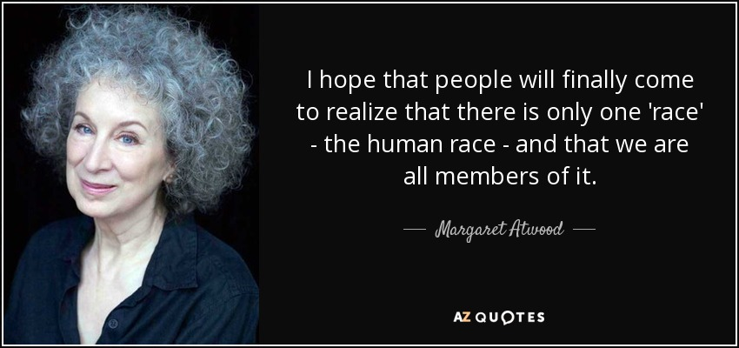
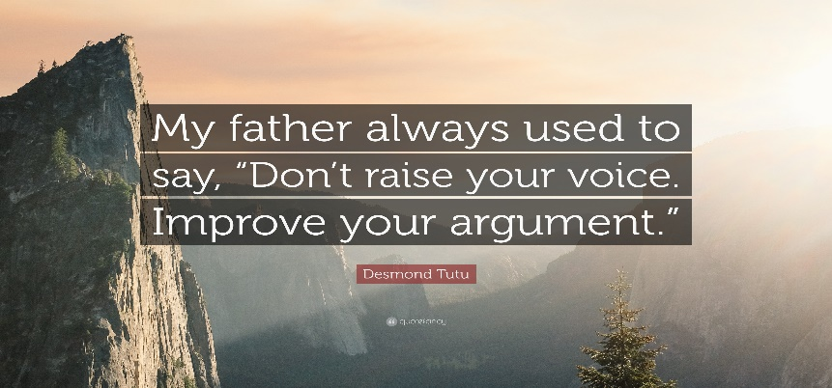

‘An eye for an eye makes the whole world blind.’ Write a speech in which you argue for this statement and persuade people to understand that, for everyone’s sake, we must move forward with a greater sense of compassion and humanity.
(24 marks for content and organisation 16 marks for technical accuracy) [40 marks]
Plan your answer to Question 5 before you start to write.

