Higher Tier
End of Year 9 test 2019 Time allowed: 1 hour 30 minutes

Question | Mark
1
2
3
4
5
6
7
8
9
10
11
12
Total
Materials
For this paper you must have:
• a ruler
• a scientific calculator
• the periodic table.

Instructions
• Use black ink or black ball-point pen.
• Fill in the boxes at the top of this page.
• Answer all questions in the spaces provided.
• Do all rough work in this book.
Cross through any work you do not want to be marked.
• In all calculations, show clearly how you work out your answer.

Information
• The maximum mark for this paper is 88.
• The marks for questions are shown in brackets.
• You are expected to use a calculator where appropriate.
• You are reminded of the need for good English and clear presentation in your answers.
Q1.
The image below shows some muscle cells from the wall of the stomach, as seen through a light microscope.
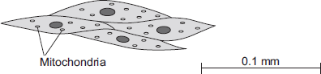
(a) Describe the function of muscle cells in the wall of the stomach.
___________________________________________________________________
___________________________________________________________________
___________________________________________________________________
___________________________________________________________________
(2)
(b) Figure above is highly magnified.
The scale bar in Figure above represents 0.1 mm.
Use a ruler to measure the length of the scale bar and then calculate the magnification of Figure above.
___________________________________________________________________
___________________________________________________________________
___________________________________________________________________
___________________________________________________________________
Magnification = _______________ times
(2)
(c) The muscle cells in Figure above contain many mitochondria.
What is the function of mitochondria?
___________________________________________________________________
___________________________________________________________________
___________________________________________________________________
___________________________________________________________________
(2)
(d) The muscle cells also contain many ribosomes. The ribosomes cannot be seen in Figure above.
(i) What is the function of a ribosome?
______________________________________________________________
______________________________________________________________
(1)
(ii) Suggest why the ribosomes cannot be seen through a light microscope.
______________________________________________________________
______________________________________________________________
(1)
(Total 8 marks)
Q2.
Some students set up the equipment below to investigate osmosis.
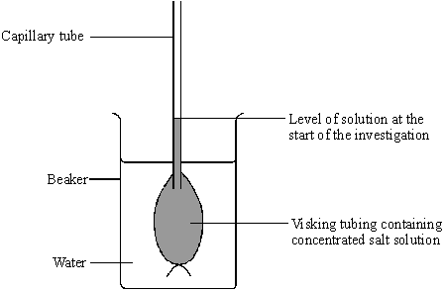
(a) What is osmosis?
___________________________________________________________________
___________________________________________________________________
___________________________________________________________________
(3)
(b) (i) What will happen to the water level in the capillary tube during the investigation because of osmosis?
______________________________________________________________
(1)
(ii) Use your knowledge of osmosis to explain why this happens.
______________________________________________________________
(2)
(Total 6 marks)
Q3.
During exercise, the heart beats faster and with greater force.
The ‘heart rate’ is the number of times the heart beats each minute.The volume of blood that travels out of the heart each time the heart beats is called the ‘stroke volume’.
In an investigation, Person 1 and Person 2 ran as fast as they could for 1 minute. Scientists measured the heart rates and stroke volumes of Person 1 and Person 2 at rest, during the exercise and after the exercise.
The graph below shows the scientists’ results.
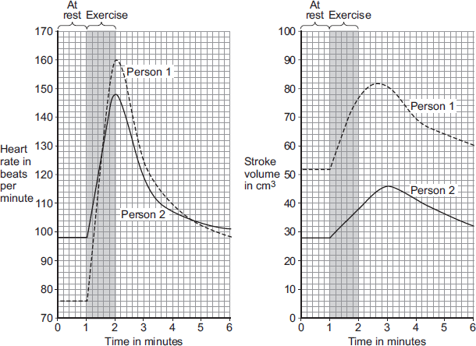
(a) The ‘cardiac output’ is the volume of blood sent from the heart to the muscles each minute.
Cardiac output = Heart rate × Stroke volume
At the end of the exercise, Person 1’s cardiac output = 160 × 77 = 12 320 cm³ per minute.
Use information from Figure above to complete the following calculation of Person 2’s cardiac output at the end of the exercise.
At the end of the exercise:
Person 2’s heart rate = _______________ beats per minute
Person 2’s stroke volume = _______________ cm³
Person 2’s cardiac output = _______________ cm³ per minute
(3)
(b) Person 2 had a much lower cardiac output than Person 1.
(i) Use information from Figure above to suggest the main reason for the lower cardiac output of Person 2.
______________________________________________________________
______________________________________________________________
(1)
(ii) Person 1 was able to run much faster than Person 2.
Use information from Figure above and your own knowledge to explain why.
______________________________________________________________
______________________________________________________________
______________________________________________________________
______________________________________________________________
______________________________________________________________
______________________________________________________________
______________________________________________________________
______________________________________________________________
______________________________________________________________
______________________________________________________________
(5)
(Total 9 marks)
Q4.
Drugs are used to treat cardiovascular diseases (diseases of the heart and blood vessels).
(a) What is a drug?
___________________________________________________________________
___________________________________________________________________
(1)
(b) People can be treated for cardiovascular diseases with statins or aspirin.
Information about these two drugs is given in the table on the next page.

STATINS | ASPIRIN
Statins are only available on prescription from doctors. | Aspirin can be bought over the counter.  Treatment with aspirin costs up to £15 per year.
In studies, 30 000 patients were monitored  over several years. Statins were found to reduce the rate of non-fatal heart attacks by about 30%. | In a study of 1000 patients, aspirin was found to cause bleeding of the stomach in around 0.5% of patients and there was a slightly increased risk of poor blood clotting at cuts.
Approximately 0.1% of the patients suffered serious muscle damage and 0.01% suffered kidney failure. | There was a slightly increased risk of damage to the blood vessels in the brain in older patients.
Statins reduce blood cholesterol which builds up in the walls of blood vessels. The cost of treating patients with statins can vary between £150 and £500 per year, depending on the type of cardiovascular disease being treated. | Aspirin was found to reduce the risk of non-fatal heart attacks by 31%.
Would you recommend statins or aspirin for the treatment of cardiovascular diseases?
In your answer you should:
• give your recommendation
• use information from the table to support your recommendation by making comparisons of the two drugs.
______________________________________________________________
______________________________________________________________
______________________________________________________________
______________________________________________________________
______________________________________________________________
______________________________________________________________
______________________________________________________________
______________________________________________________________
______________________________________________________________
______________________________________________________________
______________________________________________________________
(5)
(Total 6 marks)

CHEMISTRY
Q5.
There are eight elements in the second row (lithium to neon) of the periodic table.
(a) Figure 1 shows an atom with two energy levels (shells).
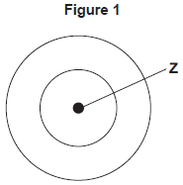
(i) Complete Figure 1 to show the electronic structure of a boron atom.
(1)
(ii) What does the central part labelled Z represent in Figure 1?
____________________________________
(1)
(iii) Name the sub-atomic particles in part Z of a boron atom.
Give the relative charges of these sub-atomic particles.
______________________________________________________________
______________________________________________________________
______________________________________________________________
(3)
(b) The electronic structure of a neon atom shown in Figure 2 is not correct.
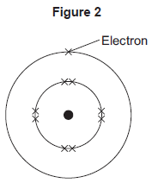
Explain what is wrong with the electronic structure shown in Figure 2.
___________________________________________________________________
___________________________________________________________________
___________________________________________________________________
___________________________________________________________________
___________________________________________________________________
___________________________________________________________________
(3)
(Total 8 marks)
Q6.
This question is about elements and the periodic table.
(a) Newlands and Mendeleev both produced early versions of the periodic table.
(i) Complete the sentence.
In their periodic tables, Newlands and Mendeleev arranged the elements in
order of __________________________ .
(1)
(ii) Name the particle that allowed the elements to be arranged in order of their atomic number in the modern periodic table.
____________________________________
(1)
(b) The diagram below shows the position of nine elements in the modern periodic table.
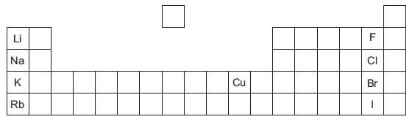
(i) Which one of the nine elements shown in the diagram above has the lowest boiling point?
____________________________________
(1)
(ii) Copper and potassium have different melting points and boiling points.
Give one other difference between the properties of copper and potassium.
______________________________________________________________
______________________________________________________________
(1)
(iii) Explain why the reactivity of the elements increases going down Group 1 from lithium to rubidium but decreases going down Group 7 from fluorine to iodine.
______________________________________________________________
______________________________________________________________
______________________________________________________________
______________________________________________________________
______________________________________________________________
______________________________________________________________
______________________________________________________________
______________________________________________________________
______________________________________________________________
______________________________________________________________
______________________________________________________________
______________________________________________________________
(4)
(Total 8 marks)
Q7.
Scientists have recently developed a method to produce large sheets of a substance called graphene.
Graphene is made from carbon and is a single layer of graphite just one atom thick.

The properties of graphene include:
• it conducts electricity
• it is transparent since it is only one atom thick
• it is strong and durable.
These properties make it suitable to overlay a monitor screen to make it a touchscreen.

The photograph below shows the structure of graphene.
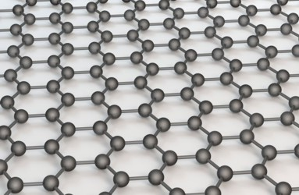
Photographs supplied by iStockphoto/Thinkstock
Use your knowledge of the bonding in graphite and the photograph of the structure to help you to explain, as fully as you can:
(a) (i) why graphene is strong;
______________________________________________________________
______________________________________________________________
______________________________________________________________
______________________________________________________________
______________________________________________________________
______________________________________________________________
(3)
(ii) why graphene conducts electricity.
______________________________________________________________
______________________________________________________________
______________________________________________________________
______________________________________________________________
______________________________________________________________
(2)
(b) Suggest why a sheet of graphite which has a large number of carbon layers would not be suitable for the touchscreen.
___________________________________________________________________
___________________________________________________________________
(1)
(Total 6 marks)
Q8.
Iron is used (as steel) to make the body panels for cars.
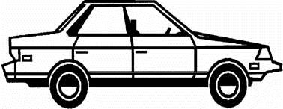
The iron panels have to be bendable so that they can be pressed into the shape required, but must also be strong. The panels must also be able to conduct electricity because they form part of the electrical circuits of the car.
(a) Iron is a typical metal. Describe the structure and bonding in a metal such as iron. You may use a diagram if you wish.
___________________________________________________________________
___________________________________________________________________
___________________________________________________________________
___________________________________________________________________
___________________________________________________________________
___________________________________________________________________
___________________________________________________________________
(4)
(b) Explain how the structure and bonding of iron:
(i) allows the body panels to conduct electricity;
______________________________________________________________
(2)
(ii) allows the body panels to be bent into shape;
______________________________________________________________
(1)
(iii) gives the body panels strength.
______________________________________________________________
(1)
(Total 8 marks)
PHYSICS
Q9.
A student finds some information about energy-saving light bulbs.
(a) A 30W light bulb uses 600J of electrical energy in a certain period of time. In that time, it produces 450 J of light energy. The rest of the energy is wasted.
(i) Calculate the energy wasted by the light bulb in this period of time.
______________________________________________________________
Wasted energy = _________________ J
(1)
(ii) What happens to the energy wasted by the light bulb?
______________________________________________________________
______________________________________________________________
(1)
(iii) Calculate the efficiency of this light bulb.
______________________________________________________________
______________________________________________________________
Efficiency = ______________________________
(2)
(iv) Calculate the period of time, in seconds, during which the 600 J is provided to the 30 W light bulb.
______________________________________________________________
______________________________________________________________
Time = _____________ s
(2)
(b) A company that makes light bulbs provides information about some of their products.
The table shows some of this information.

 | Power in watts | Lifetime in hours | Cost of bulb in £
Filament bulb | 60 | 1250 | 2.00
LED bulb | 12 | 50 000 | 16.00

(i) Suggest why it is important to confirm this information independently.
______________________________________________________________
(1)
(ii) A homeowner is thinking about replacing his filament bulbs with LED bulbs.
A 12 W LED bulb gives the same light output as a 60 W filament bulb.
Suggest reasons why the homeowner is likely to choose LED bulbs.
Use the information given in the table.
______________________________________________________________
______________________________________________________________
______________________________________________________________
______________________________________________________________
(2)
(iii) State one factor, other than efficiency, that is important when considering the choice of a bulb for lighting in the home.
______________________________________________________________
______________________________________________________________
(1)
(Total 10 marks)
Q10.
A student uses an electric motor to lift a load.
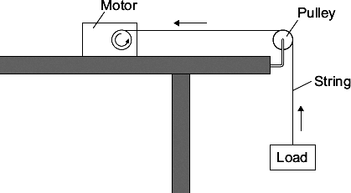
In the motor, the electrical energy is transferred into other types of energy. Some of this energy is useful and the rest of the energy is wasted.
(a) (i) Name the useful energy output from the electric motor.
______________________________________________________________
(1)
(ii) What eventually happens to the wasted energy?
______________________________________________________________
______________________________________________________________
(1)
(b) The graph shows the input energy the motor needs to lift different loads by one metre.
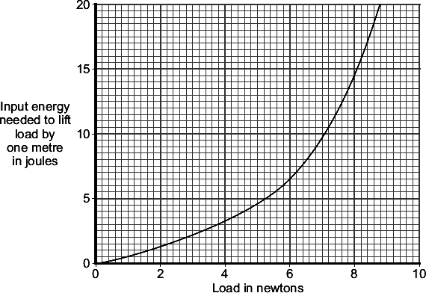
What can you conclude from the graph about the relationship between the load lifted and the input energy needed?
___________________________________________________________________
___________________________________________________________________
___________________________________________________________________
___________________________________________________________________
(2)

(c) | A shop uses escalators to lift customers to different floor levels. The escalators use electric motors. When the shop is not busy some escalators are turned off. A sign tells the customers that the escalators are turned off to save energy. | 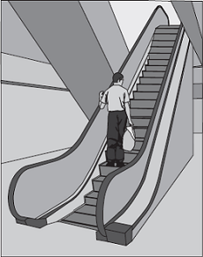
(i) Each escalator has one motor with an average power of 4000 W. The motor is turned on for an average of 8 hours each day, 6 days each week. Electricity costs 15 pence per kilowatt-hour.
Calculate the cost of the electricity used in an average week to run one escalator.
Show clearly how you work out your answer.
______________________________________________________________
______________________________________________________________
______________________________________________________________
______________________________________________________________
Cost = _______________________ pence
(3)
(ii) Give one environmental advantage to turning off electrical appliances when they are not being used.
______________________________________________________________
______________________________________________________________
(1)
(Total 8 marks)
Q11.
The miners working in a salt mine use smooth wooden slides to move quickly from one level to another.
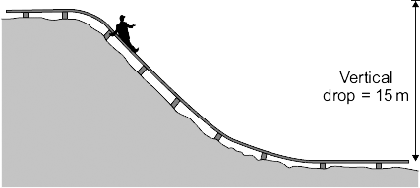
(a) A miner of mass 90 kg travels down the slide.
Calculate the change in gravitational potential energy of the miner when he moves 15 m vertically downwards.

gravitational field strength = 10 N/kg
Show clearly how you work out your answer.
___________________________________________________________________
___________________________________________________________________
Change in gravitational potential energy = _________________________ J
(2)
(b) Calculate the maximum possible speed that the miner could reach at the bottom of the slide.
Show clearly how you work out your answer.
Give your answer to an appropriate number of significant figures.
___________________________________________________________________
___________________________________________________________________
___________________________________________________________________
___________________________________________________________________
Maximum possible speed = _________________________ m/s
(3)
(c) The speed of the miner at the bottom of the slide is much less than the calculated maximum possible speed.
Explain why.
___________________________________________________________________
___________________________________________________________________
___________________________________________________________________
___________________________________________________________________
___________________________________________________________________
___________________________________________________________________
___________________________________________________________________
(3)
(Total 8 marks)
Q12.
The diagram shows a wind turbine.
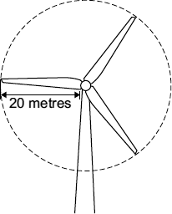
(a) The blades of the turbine are 20 metres long. On average, 15 000 kg of air, moving at a speed of 12 m/s, hit the blades every second.
Calculate the kinetic energy of the air hitting the blades every second.
Show clearly how you work out your answer.
___________________________________________________________________
___________________________________________________________________
Kinetic energy = _________________________ J
(2)
(b) Part of the kinetic energy of the wind is transformed into electrical energy.
The diagram shows that, for the same wind speed, the power output of a turbine, in kilowatts, depends on the length of the turbine blades.
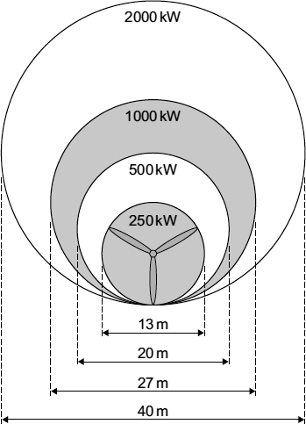
Give a reason why doubling the diameter of the blades more than doubles the power output of a turbine.
___________________________________________________________________
___________________________________________________________________
(1)
(Total 3 marks)

END OF TEST

