Summer Task:
Your job is to create research project notes on 3 of the following tectonic events.
1991: Mt Pinatubo (The Philippines as a multiple hazard zone).
1995-1997: Montserrat
2004: Asian Tsunami
2010: Eyjafjallajokull
2010: Haiti
2011: Tohoku Earthquake and Tsunami
You should pick one HIC, one LIC and one NIC country for comparison purposes. The grid provided is for your notes.
You must also write a list of Harvard style references for each website book or video you have used for your research information. This is an important skill that you need to practice. Here is an example of what to do and how it should look:
Books:
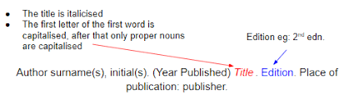
Websites:
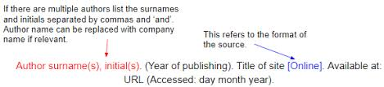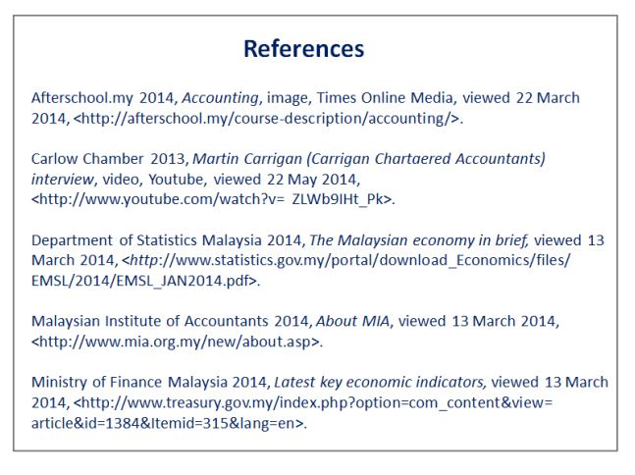
Case Study Title:
Description of Global Location | Place Profile (Country background - HIC/LIC/NIC? Factors linking to levels of vulnerability e.g. education?)
Plate Boundary name and type – links to continental crust and oceanic crust here too | Cause of the event (what happened at the plate boundary – diagram here?)  Magnitude of the event:
Primary Impacts (effects) e.g. ground shaking, lava flows etc | Secondary Impacts (effects) don’t forget social and economic impact categories
Response to the event – long term and short term | Governance and aid – who was in charge or helped with disaster management?
Speed of recovery? Are they back to normal? | Cost of the event?
Case Study Title:
Description of Global Location | Place Profile (Country background - HIC/LIC/NIC? Factors linking to levels of vulnerability e.g. education?)
Plate Boundary name and type – links to continental crust and oceanic crust here too | Cause of the event (what happened at the plate boundary – diagram here?)  Magnitude of the event:
Primary Impacts (effects) e.g. ground shaking, lava flows etc | Secondary Impacts (effects) don’t forget social and economic impact categories
Response to the event – long term and short term | Governance and aid – who was in charge or helped with disaster management?
Speed of recovery? Are they back to normal? | Cost of the event?
Case Study Title:
Description of Global Location | Place Profile (Country background - HIC/LIC/NIC? Factors linking to levels of vulnerability e.g. education?)
Plate Boundary name and type – links to continental crust and oceanic crust here too | Cause of the event (what happened at the plate boundary – diagram here?)  Magnitude of the event:
Primary Impacts (effects) e.g. ground shaking, lava flows etc | Secondary Impacts (effects) don’t forget social and economic impact categories
Response to the event – long term and short term | Governance and aid – who was in charge or helped with disaster management?
Speed of recovery? Are they back to normal? | Cost of the event?

