**Sociology Bridging Task**

|  |  |
| --- | --- |
| **QUALIFICATION** | **A-level Sociology** |
| Teacher Name(s) | Mrs Rajput |
| Contact email(s) | a.rajput@bishopullathorne.co.uk |
| Exam board and link | AQA www.aqa.org.uk |
| Recommended online learning | <https://revisesociology.com/>  <https://www.senecalearning.com/>  <https://www.tutor2u.net/sociology>  <https://www.aqa.org.uk/subjects/sociology/as-and-a-level/sociology-7191-7192>  <https://thesociologyguy.com/a-level-sociology/>  <https://www.youtube.com/channel/UC6VpoZj33Df_rNb8KymCczw>  <https://napierpress.com/> |
| Textbooks that are used | AQA A Level Sociology Book One Including AS Level: Book one  by Rob Webb  published by Napier Press    Sociology Themes and Perspectives - Haralambos and Holborn (Paperback)  Published by Collins  AQA A Level Sociology Student Book 1 (Collins AQA A Level ...  By Steve Chapman  Published by Collins  AQA Sociology for A-level Book 1: Amazon.co.uk: David Bown, Laura ...  By David Brown  Published by Hodder  A-Level Sociology: AQA Year 1 & 2 Complete Revision & Practice (Paperback)  Published By CGP |

In addition, the this pack may contain resources like PowerPoints, assessments and activities for you to try at home over the summer.

We recommend you use Cornell Notes to prepare for your new course. Please see this video to help you develop the technique:

[**https://youtu.be/WtW9IyE04OQ**](https://youtu.be/WtW9IyE04OQ)

Please complete the activities in this booklet in readiness to begin your studies when we are told Sixth Form may reopen. This will show us your commitment and may be used alongside your GCSE grades as entry criteria – Sixth Form study is hard work and there are no short cuts. Commitment to your studies is essential.

Good Luck and Stay Safe!

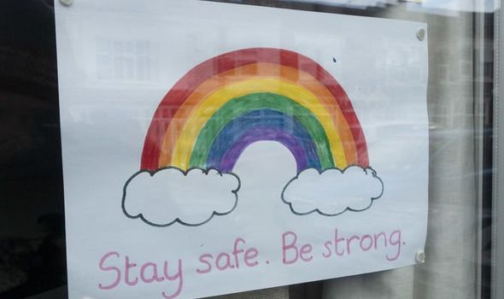

**Welcome to A-level Sociology!**

You have chosen a subject that will ‘keep you on your toes’ and make you think in ways you couldn’t imagine. You will certainly have a very different outlook on society by the end of your course.

**Overview of the course:**

This is a two-year course which ends with **three** two-hour papers each carrying an equal weighting towards your final A-level grade (A*-E).

Topics we will cover will include:

Year 12 Year 13

Theories of Sociology Crime and Deviance

Methods of Sociology Beliefs in Society

Families & Households Methods of Sociology

Education Theories of Sociology

Look at the specification for more detail about these topics. You can find this at: <https://filestore.aqa.org.uk/resources/sociology/specifications/AQA-7191-7192-SP-2015.PDF>

You will be expected to know and understand **(AO1)** the information about the topics, to be able to apply **(AO2)** that knowledge and understanding and to be able to analyse and evaluate **(AO3)** that knowledge and understanding.

***Task 1***

Read the specification carefully and make a note below of the sections there are to each topic:

Education……………………………………………………………………………………..………………

.………………………………………………………………………………….………………………………

…………………………………………………………………...................................................................

Theory and Methods (Year 1)…………………………..…………………………………………………

………………………………………………………………………………………………….………………

…………………………………………………………………...…………………………………………...…

Families and Households….………………………………………………………………………………..

…………………………………………………………………………………………………........................

…………………………………………………………………………………………………........................

Beliefs in Society……………………………………………………………………………………………..

………………………………………………………………………………………………….………………

…………………………………………………………………..……………………………………………..

Crime and Deviance ………………………………………………………………………………………

…………………………………………………………………………………………………………………..

………………………………….……………………………………………………………………………….

Theory and Methods (Year 2) ………………………………………………….…………………………

…………………………………………………………………………………………………………………..

…………………………………………………………………………………………………………………..

What do you think ‘Methods in Context’ means?

…………………………………………………………………………………………………………………

…………………………………………………………………………………………………………………

…………………………………………………………………………………………………………………

**Expectations of the course:**

* Lessons consist of taking notes, group discussions, watching relevant DVDs/documentaries, group work and PowerPoint presentations.
* Homework consists of note making, wider reading, research, past exam questions, power points and essays.
* The ***Reading and Watching List*** on the following page will help you to gain wider knowledge and a broader framework in which to apply your knowledge.
* Your progress will be reviewed on a regular basis. The review process will provide feedback at specific times throughout the year.
* Make a Sociology chat/whatsapp for discussion.
* Your folders of notes will be checked on a regular basis to see if you are organised and up to date with your work.
* USE YOUR STUDY TIME AND BE PRO-ACTIVE.

*Reading List - Sociology*

* Brave New World – Aldous Huxley
* Animal Farm – George Orwell
* 1984 – George Orwell
* Chavs: The Demonisation of the Working Class – Owen Jones
* The Establishment and How They Get Away With It – Owen Jones
* The Handmaid’s Tale – Margaret Atwood (also a series)
* Vox – Christina Dalcher
* The God Delusion – Richard Dawkins
* Outsiders: Studies in Sociology of Deviance – Howard S Becker
* Folk Devils and Moral Panics – Stanley Cohen
* A Glasgow Gang Observed – Patrick James
* Gang Leader For A Day – Sudhir Venkatesh
* Haralambos
* A wide range of newspapers including The Guardian and Independent

*Watching List - Sociology*

* Any documentaries, including Panorama, Louis Theroux, Stacey Dooley, Mind of a Murderer etc
* Black Mirror series (Netflix)
* Years and Years (BBC i-player)
* Goodfellas
* The Godfather (part 2 is the best)
* Legend
* My Scientology Movie
* The ‘Up’ series (eg. 56 Up, 63 Up) on Netflix or Youtube
* The Secret Life of 5 year olds
* McMafia (previously BBC i-player)
* Freedom Writer’s Diary
* Dangerous Minds
* Chernobyl (drama)
* When They See Us (Netflix)
* The Society (Netflix)
* Blood Diamond
* A Bug’s Life or Antz (for Marxism)
* Ted Talks/Sociology

***Task 2***

Choose something from the Reading and Watching List that you are going to report on in your first Sociology lesson.

***Task 3***

Use the following link (<https://hecticteachersalevelsociologysite.wordpress.com/unit-1-education-with-methods-in-context/roles-and-purpose-of-education/functionalist-view/> ) and any of the links above to research ‘functionalism’, ‘Marxism’ and ‘feminism’ (type these into the search engine).

You do not need to research these sociological theories in too much depth – just a simple overview. Write an overview of the theories:

|  |  |
| --- | --- |
| Theory | Brief overview |
| Functionalism |  |
| Marxism |  |
| Feminism |  |

***Task 4***

Watch the following clip and jot down 5 things that tell you what Sociology is.

<https://www.youtube.com/watch?v=YnCJU6PaCio>

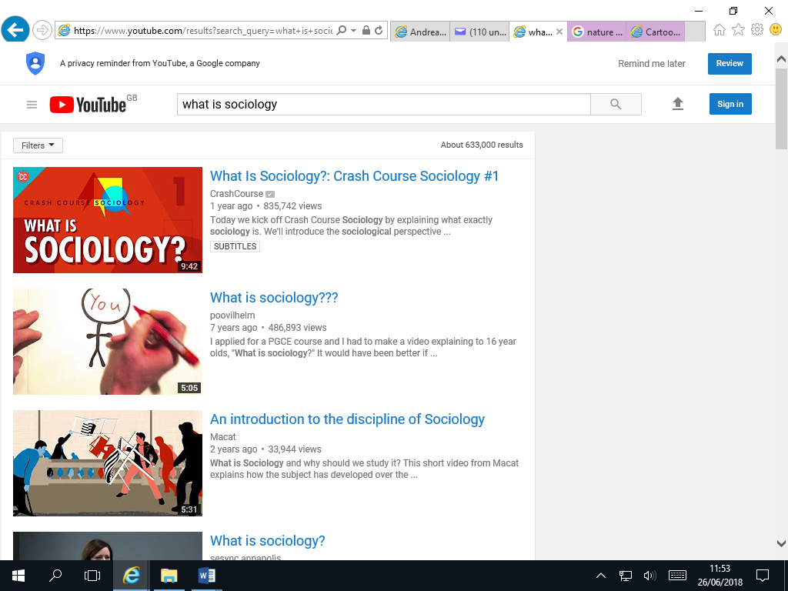

[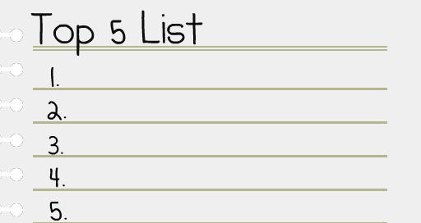](https://www.google.com/url?sa=i&rct=j&q=&esrc=s&source=images&cd=&cad=rja&uact=8&ved=2ahUKEwjqrrnnmvHbAhXiJsAKHVe2D3UQjRx6BAgBEAU&url=https://melissafoster.com/time-management-tips-following-through-commitments-limited-time/&psig=AOvVaw2_2_YFqRQyGw9LEUIgtpZI&ust=1530098356438301)

An Introduction to A-level Sociology

[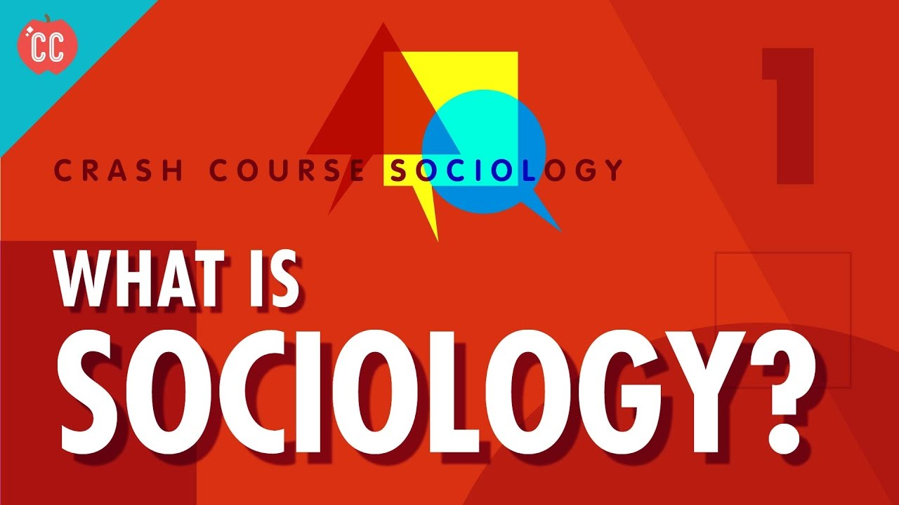](https://www.google.com/url?sa=i&rct=j&q=&esrc=s&source=images&cd=&cad=rja&uact=8&ved=2ahUKEwjNv7T5kPHbAhVG1RQKHbzMCg8QjRx6BAgBEAU&url=https://www.youtube.com/watch?v%3DYnCJU6PaCio&psig=AOvVaw35_fxVT9ifNaQlRES85LAw&ust=1530095622186461)

**Sociology** is the study of human social life. There are many different aspects of Sociology to address, so you must be curious and attentive to looking at the world in a different way!

[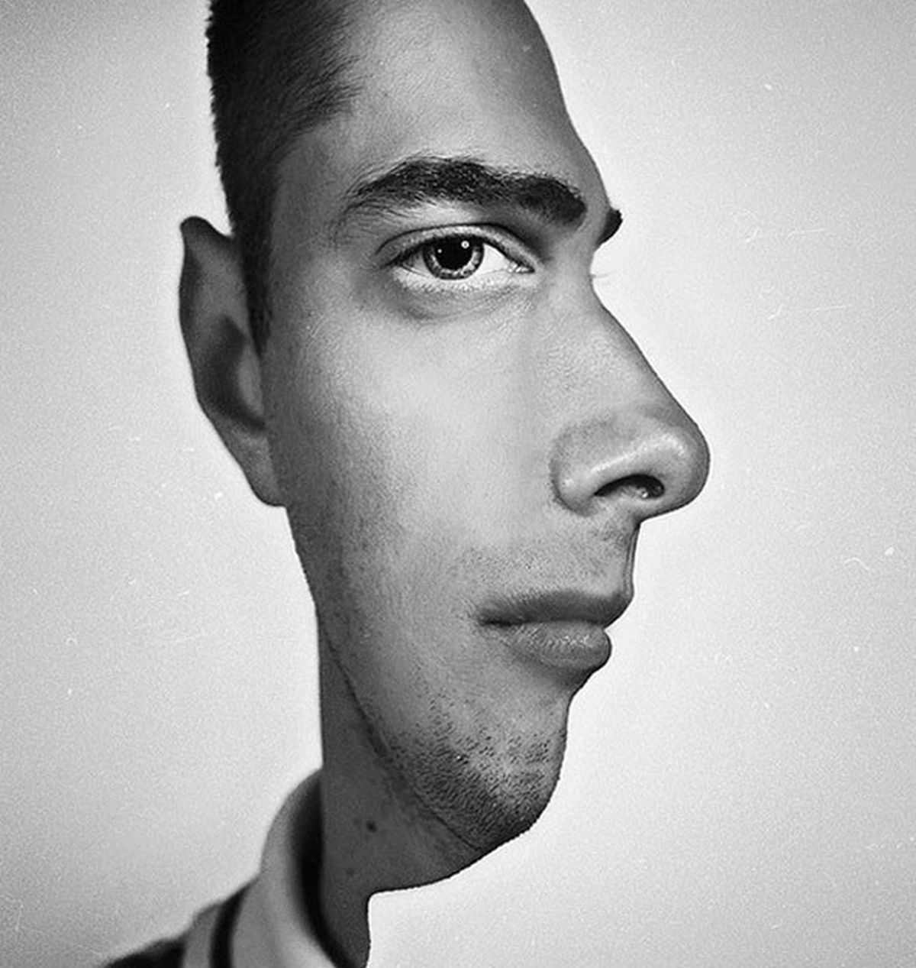](https://www.google.co.uk/url?sa=i&rct=j&q=&esrc=s&source=images&cd=&cad=rja&uact=8&ved=2ahUKEwjigqiopOLbAhVMVxQKHWZzBw0QjRx6BAgBEAU&url=https://www.seenox.org/incredible-visual-illusions-will-make-you-feel-like-on-drugs/&psig=AOvVaw3FBeiv_qt64EG9G-NAIyRO&ust=1529585523353145)

Look at this photograph; not everything is as it seems!

There is usually another way of looking at things – and that is what we do as sociologists.

We take normal, taken-for-granted life and turn it upside down, looking for meanings. And very often we end up seeing things very differently.

*Social Change*

The social world is changing. Some argue it is growing; others say it is shrinking. The important point to grasp is: society does not remain static over time; it constantly changes - through decades and centuries and across countries, societies.

***Task 5***

Think of 3 different ways society has changed over the last 100 years. Try to be specific about the change eg. homosexuality is no longer illegal.

…………………………………………………………………………………………………………………………………………………………………………

…………………………………………………………………………………………………………………………………………………………………………

…………………………………………………………………………………………………………………………………………………………………………

Now, name 3 ways in which British society is different to another (America, Italy etc.)

………………………………………………………………………………………………………

………………………………………………………………………………………………………

………………………………………………………………………………………………………

………………………………………………………………………………………………………

…………………………………………………………………………………………………………………………………………………

…………………………………………………………………………………………………………………………………………………

***Task 6***

Why do you think society has changed? Why are societies different?

…………………………………………………………………………………………………………………………………………………………………………

…………………………………………………………………………………………………………………………………………………………………………

…………………………………………………………………………………………………………………………………………………………………………

…………………………………………………………………………………………………………………………………………………………………………

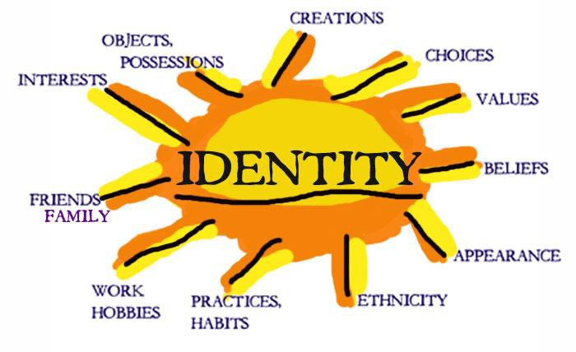**Identity**

Who are you? Are you part of a group, an individual, a student, a sister, a brother?

**Identity** is about how we

see and define ourselves –

our personalities – and how

other people see and define us. Many aspects of our individual identity are influenced by

**agencies of socialisation**. These are structures or groups of people.

***Task 7***

Suggest four examples of structures or groups of people that impact upon you:

……………………………………………………………………………………………………………………………………………………………………

……………………………………………………………………………………………………………………………………………………………………

……………………………………………………………………………………………………………………………………………………………………

……………………………………………………………………………………………………………………………………………………………………

……………………………………………………………………………………………………………………………………………………………………

……………………………………………………………………………………………………………………………………………………………………

……………………………………………………………………………………………………………………………………………………………………

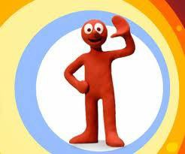Individuals are like moulded putty, squished and squashed by society and its **structures**, but there are decisions we make that are driven by internal motivations. Behaviour that comes from within us – decisions we make in order to do things - is called **agency**. Agency behaviour is meaningful and a reflection of self-will. Sometimes we can challenge and oppose structures, and in this way we help construct a part of our identity.

***Task 8***

List three agency decisions you have made or will make today.

1. ………………………………………………………………………………………………………………

2. ………………………………………………………………………………………………………………

3. …………………………………………………………………………………………………………………

***Task 9***

Make a poster of how your identity is shaped by factors in your life.

Consider **agency** factors and **structural** factors.

Brainstorm some ideas first on what you can include in your poster.

……………………………………………………………………………………………………………………………………………………………………

……………………………………………………………………………………………………………………………………………………………………

……………………………………………………………………………………………………………………………………………………………………

……………………………………………………………………………………………………………………………………………………………………

……………………………………………………………………………………………………………………………………………………………………

……………………………………………………………………………………………………………………………………………………………………

……………………………………………………………………………………………………………………………………………………………………

……………………………………………………………………………………………………………………………………………………………………

***Nature vs Nurture – The Big Debate***



There are many ways of explaining why certain people do things in certain ways. For example, biologists think that people behave as they do because they are controlled by nature. This is known as **Nature theory**. Humans are compared to animals and seen to act on **instinct**.

Sociologists believe that people behave as they do because they are taught how to behave. For example, the sociologist Michael Haralambos states, ‘Human beings learn their behavior and use their intelligence whereas animals simply act on instinct.’ This is known as **Nurture theory**. Nurture means the way you are brought up. It is also a reference to **socialisation**, the lifelong process by which we learn our culture, values, norms and how to behave.

***Task 10***

Write down a list of things that you were taught by other people about how to behave eg. how to speak etc.

………………………………………………………………………………………………………………………………………………………………

………………………………………………………………………………………………………………………………………………………………

………………………………………………………………………………………………………………………………………………………………

………………………………………………………………………………………………………………………………………………………………

………………………………………………………………………………………………………………………………………………………………

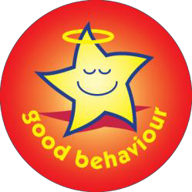Sociologists reject nature theories for two particular reasons. If people behaved as they do because of nature, they would all act the same as each other. The following reasons show why people do not all act the same:

1. ***History***: people acted differently in the past from the way that they do today. They had different ideas and different beliefs.
2. ***Anthropology:*** this is the study of different human societies. Wherever you go in the world, people act differently from the way they do in Britain.

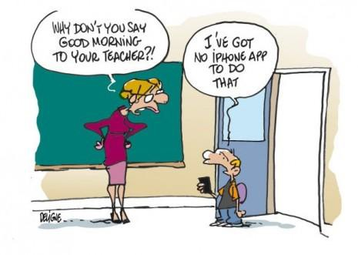**Social behaviour and culture**

Sociology is the study of human groups and social life in modern societies. Sociology recognises that as members of society we have to learn social behaviour and this is done through a variety of social institutions and social groups right throughout our lives.

|  |
| --- |
| ***Task 11***  WHAT MAKES US HUMAN?   * Are we meant to live alone? * What would a person be like if they grew up without human contact? * What would a person be like if they were then introduced into a society? * Do we need a society in which to survive? * Can someone be truly human if they grew up without human contact? * Are we ruled by our instincts? (An instinct can be defined as a complex, unlearned pattern of behaviour that is universal in a species).   Watch the video and compare how, as children, we behave and how Oksana behaves. What has been the impact of the lack of human contact?  <https://www.youtube.com/watch?v=nv3ocntSSUU> |

It should have become clear that humans, more than most other animals, are dependent upon other humans for the most basic needs such as food and shelter.

We do not arrive in this world equipped with a collection of instincts inherited from our parents that will enable us to survive in a potentially hostile environment.



Virtually all the things that we do have to be learned from others, for example walking, speaking, knowing what to eat, defending ourselves etc. A desert island baby is unlikely to survive, therefore we need other people.

We have now established an important principle. Human behaviour is largely learned through a process called ***socialisation.*** Therefore what is termed as **culture,** which is our way of life, including the ways in which we behave relates to:

- the language we speak

- the clothes we wear

- the food we eat and whether we eat it with knives, forks and spoons

- the homes we live in

- to the things we believe about the origins of life

- what is good or bad

- or the ways in which we should be governed.

The above are all acquired from other people (this involves the process of **socialisation** into the **culture** of our society)

|  |
| --- |
| ***Task 12***  Using the above list, describe the British culture. |

It is through our membership of social groups that we acquire an understanding of the ways in which behaviour is patterned and organised and of the **values**, customs, **norms** and **roles** of our society. Sociologists refer to this as **culture** — the learned, shared behaviour of members of society. Culture is a social blueprint, a guide for living. It refers to all the aspects of human behaviour that are learnt rather than genetically transmitted. The following activity shows you the importance of culture.

A **subculture** is a culture within a broader mainstream culture, with its own separate values, practices, and beliefs eg. Bikers, goths, skateboarders, scousers, yuppies, hippies etc.

***Task 13***



Read the following.What aspects of this culture seem alien? In what ways can this resemble British culture?

*The Shirbit Tribe*

The Shirbit culture believes that the human body is ugly and feeble. The Shirbit, therefore, indulge in rituals and ceremonies designed to avoid this, and so every household has a shrine devoted to the body.

The rituals associated with the shrine are private and secret. Adults do not discuss the rituals and children are only told enough for them to be successfully initiated.

The focal point of the shrine is a box built into the wall where key charms and magical potions for the face and body are kept. These are obtained from medicine men, who write down the ingredients in an ancient and secret language, understood only by the herbalist who prepares the potion.

Beneath the charm-box, is a small font. Every day, every member of the family enters the shrine chamber in succession and bows their head before the charm-box, mingling all sorts of holy water in the font and proceeds with a brief rite of absolution.

The Shirbit have a pathological horror of and fascination with the mouth, the condition of which is believed to have a supernatural influence on all social relationships. Were it not for the rituals of the mouth, they believe their teeth would fall out, their friends would desert them and their lovers would reject them.

Finally, men and women indulge in barbaric acts of self-mutilation. Men engage in a daily body ritual of scraping and lacerating their faces with a sharp instrument, whilst women bake their heads and hair with scorching tools.

***Did you recognise that this is British culture?***

The shrine devoted to the body is … the bathroom! The box built into the wall where charms and magical potions are kept is … a bathroom cabinet!

What do you think is meant by ‘rituals of the mouth’ or ‘ritual of scraping and lacerating faces with a sharp instrument?

*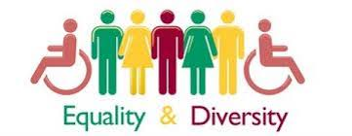****Task 14: Essay***

A-level Sociology is all about essay writing, a hugely important skill. This essay is designed to allow you to demonstrate your sociological understanding and writing skills.

You will be assessed on the quality of your written style, the level to which you have understood and can use sociological concepts, your organisational skills and ability to follow instructions.

|  |
| --- |
| **Essay title:**  **Evaluate the view that society is becoming more equal in the 21st century.**  You will need to pay particular attention to the notes which follow on socialisation and role.  You should think firstly about what is meant by ‘equality’. Consider ways you think equality has been achieved and give examples. Try to think widely and consider global issues – it may help to make comparisons with other countries/societies.  To evaluate, you need to ‘weigh up’ and make a judgement so you also need to think about how some groups in society may still experience inequality, why this might be the case and whether equality can /should be achieved. |

Your essay should have:

* Clear paragraphs, an introduction and conclusion
* Accurate spelling, punctuation and full sentences
* Correct use of grammar
* Accurate phrasing
* Discuss different types of equality eg. gender, social class, ethnicity

Your essay should be at least 500 words and ***hand written***.

You should hand in your essay when directed on your return to 6th Form.

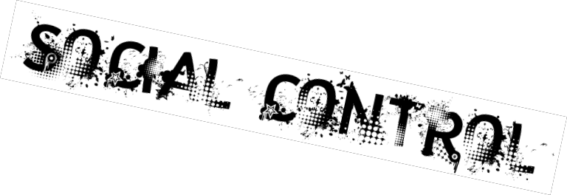

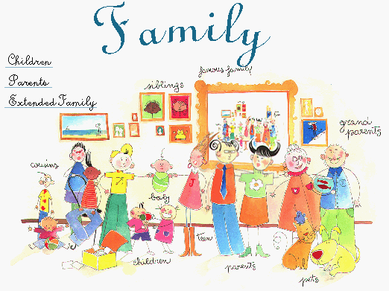Socialisation is the term that sociologists use to describe the life-long process of learning the culture of any society. Culture is socially transmitted from one generation to the next through the process of socialisation. The American sociologist Charles Cooley (1864–1929) distinguished two types of socialisation: **primary** and **secondary**. These two forms of socialisation are defined partly in terms of the particular groups or ‘agencies’ in which they occur:

***Primary socialisation***

The family is the main agency where an individual learns many of the basic lessons for life such as language, how to act as a boy or a girl, how to share and how to love.

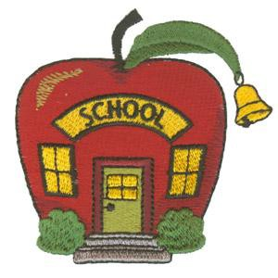

***Secondary socialisation***

Associated with the later stages of identity formation, from later childhood and continuing through adulthood. The school is an important example of an agency of secondary socialisation, but all formal organisations, including religion and work, are influential.

***Task 15***

List 2 ways in which your family teach you something. Similarly, list two ways in which

school teaches you something **(something other than subjects!).**

………………………………………………………………………………………………………………………………………………………………

………………………………………………………………………………………………………………………………………………………………

………………………………………………………………………………………………………………………………………………………………

………………………………………………………………………………………………………………………………………………………………

Socialisation is not only the process by which we learn the culture of our society; it is also a mechanism of **social control**.

This refers to methods used to persuade or force individuals to conform to those values, norms and patterns of behaviour which the culture of their society requires. Social control involves the use of rewards and punishments. Sociologists refer to these as sanctions. These may be either positive sanctions (rewards) or negative sanctions (various types of punishment):

**Positive sanctions** may range from gifts of sweets from parents to children, to merits and prizes at school, to promotion at work or to knighthoods and medals.

**Negative sanctions** may range from expressions of disapproval, physical punishment, being ridiculed or gossiped about, dismissal from work to being fined or imprisoned.

***Task 16***

List and briefly explain three positive and three negative sanctions which affect the way you behave in your daily life:

POSITIVE

**1. …………………………………………………………………………………………………**

**2. …………………………………………………………………………………………………**

**3. …………………………………………………………………………………………………**

NEGATIVE

**1. …………………………………………………………………………………………………**

**2. …………………………………………………………………………………………………**

**3. …………………………………………………………………………………………………**

***Key Concepts in Socialisation and Culture***

*Norms*

**Norms** are social rules which define correct and acceptable behaviour in a society or social group to which people are expected to conform. They are essential to human society. They guide and direct our behaviour and allow us both to understand and predict the behaviour of others.

Norms exist in all areas of social life. In Britain, being late for work or an appointment; jumping queues in supermarkets; laughing during funerals; walking through the streets naked or never saying hello to friends are likely to be seen as rude, annoying or odd because they are not following the norms of accepted behaviour.

Norms are usually enforced informally—by the disapproval of other people, embarrassment, or a ‘telling off’ from parents.

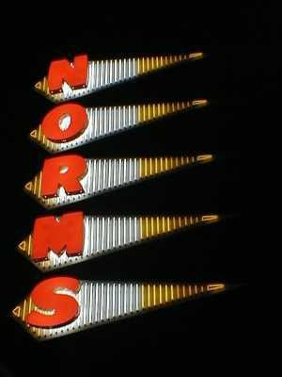

***Task 17***

Think of some norms for each of these situations.

School: ………………………………………………………………………………………………………………

…..…………………………………………………………………………………………………………………………..

……………………………………………………………………………………………………………………………….

Home: ……………………………………………………………………………………………………………….. ………………………………………………………………………………………………………………………………………………………………………………………………………………………………………………………………………………………………………………………………

Friend’s house: ………………………………………………………………………………………………………………………………

………………………………………………………………………………………………………………………………………………………………

………………………………………………………………………………………………………………………………………………………………..

***Task 18: British Norms***

Look at the following link and answer the questions.

<https://www.buzzfeed.com/alexfinnis/what-percentage-stereotypically-british-are-you>

Then, have a look at this link and summarise the main British norms.

https://www.studying-in-uk.org/british-culture-and-social-norms/

|  |
| --- |
| **What do these sources tell you about norms?** |

**Values**

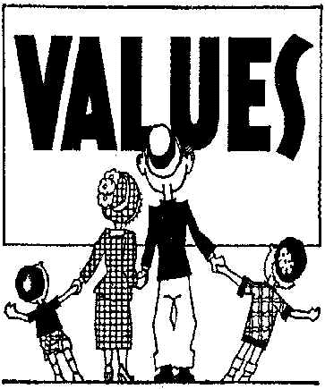

**Values** are less specific than norms. They are general guides for behaviour. Values are ideas and beliefs about what is ‘right’ and ‘wrong’ and about standards which are worth maintaining and achieving in any society. In Britain, values include beliefs about respect for human life, privacy and private property, about the importance of marriage and the importance of money and success.

There are official legal rules concerning values which are formally enforced by the police, courts and prison and involve legal punishment if they are broken. For example, laws against murder enforce the value attached to human life in our society.

***Task 19***

Think of two values that are really important to you as a person, e.g. you may have strong views about animals or children.

1…………………………………………………………………………………………………

…………………………………………………………………………………………………

2…………………………………………………………………………………………………

……………………………………………………………………………………………………

**Status**

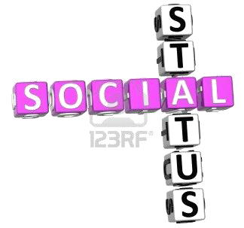

Sociologists use the term ‘status’ to refer to a position in society, for example father, doctor, son, bank manager, teacher. **Statuses** may be ascribed or achieved.

**Ascribed** statuses are fixed, often at birth, and are largely unchangeable. For example, gender and race are fixed characteristics usually given by others.

An **achieved** status involves some degree of choice and results partly from individual achievement. For example, a person achieves his or her job as a teacher, doctor or scientist on the basis of ability and effort.

**Role**

Each status has an accompanying role. A **role** is a set of norms which defines appropriate and expected behaviour for those who occupy a particular status.

A role can be compared to that of an actor on the stage following a ‘script’.

Roles are patterns of behaviour which are expected from people in different positions in society. People in society play many different roles in their lifetimes, such as those of a boy or girl, a child and an adult, a student, a parent, a friend and work roles like factory worker, police officer or teacher. People in these roles are expected by society to behave in particular ways. The police officer who steals or the teacher who is drunk in the classroom, show what these expectations of behaviour are!

***Task 20***

List some of the roles you play and briefly outline what others expect of you in each of these roles. For example, how are you expected to behave as a student/pupil and what activities are you expected to carry out which you wouldn’t have to if you were not a student?

…………………………………………………………………………………………………

…………………………………………………………………………………………………

…………………………………………………………………………………………………

…………………………………………………………………………………………………

One person plays many roles at the same time. For example, a woman may play the roles of woman, mother, worker, sister and wife at the same time. This may lead to **role conflict**, where the successful performance of two or more roles at the same time may come into conflict with one another, such as the conflict between the roles of full-time worker and mother which some women experience. For example, what happens if a child is ill? (**Note**: consider why women are referred to and not men.)

***Task 21***

From your list of roles, try to pick out two examples of those which conflict with each other. Give a brief explanation of each example of role conflict.

…………………………………………………………………………………………………..

………………………………………………………………………………………………….

……………………………………………………………………………………………….….

.……………………………………………………………………………………………….…

…………………………………………….………………………………………………........

........................................................................................................................................

........................................................................................................................................

***Task 22: Recap***

List the key words you have learned so far with their definitions in the table.

|  |  |
| --- | --- |
| *Key Term* | *Definition* |
| Sociology |  |
| Identity |  |
| Structure |  |
| Agency |  |
| Nature/Nurture |  |
| Socialisation |  |
| Culture |  |
| Norms |  |
| Values |  |
| Status |  |
| Role |  |