Becoming an Outstanding Geographer

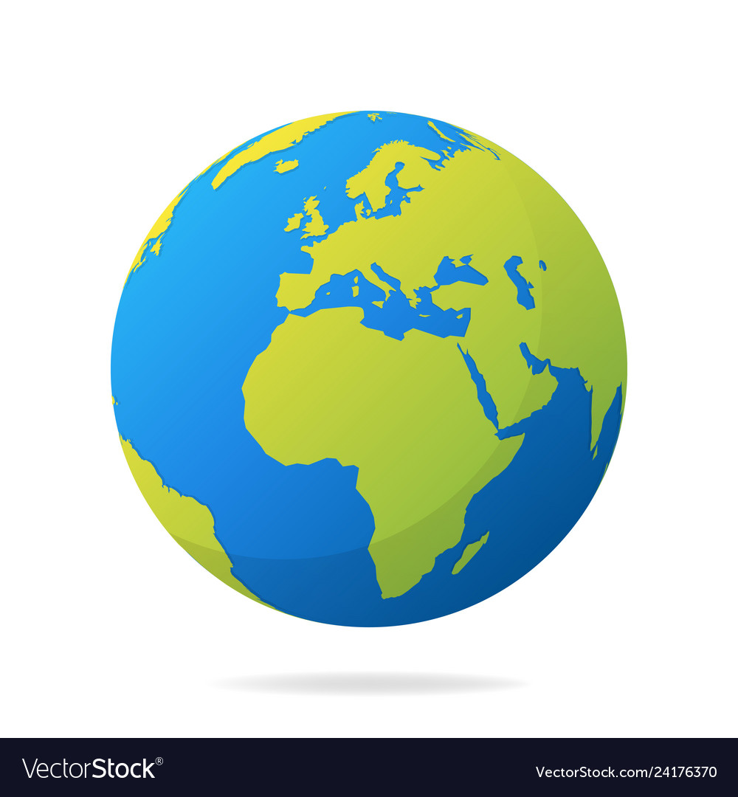

**What is geography?**

Geography is the study of places and the relationships between people and their environments. Geographers explore both the physical features of Earth and the human societies spread across it. They also examine how human culture interacts with the natural environment and the way that locations and places can have an impact on people. Geography seeks to understand where things are found, why they are there, and how they develop and change over time.

**Why is geography important for me?**

Every time you turn on the news you will see something that relates to your geography lessons. We will learn about how the natural world works – from why it rains to how volcanoes form to why our global climate is changing and how this will affect us in so many ways. We will learn about current global issues like population, migration and development and consider how humans interact with the natural environment. Geography will prepare you for jobs that do not even exist yet, as our world is ever changing. It will open your eyes to what is happening around you and prepare you to be a global citizen. At a time where our natural world faces many threats – it has never been more important to be a geographer!

**How will this booklet help me to become an outstanding geographer?**

When you start secondary school, you are not starting a new learning journey, but continuing to build on all of the things you learned in primary school. You will realise that in your geography lessons, much of what we learn links to what you studied in primary school. This booklet will help you to recall that information and refresh your memory so that you are fully prepared for the next steps of your geography journey!

**Checking My Knowledge**

*KS2 National Curriculum for Geography – RAG Checklist*

Read each statement carefully and consider if you think you are red, amber or green in that area.

Red = I think I have no knowledge in this area

Amber = I think I have some knowledge in this area

Green = I am confident in my knowledge in this area

|  |  |  |  |
| --- | --- | --- | --- |
| **Knowledge and Skills** |  |  |  |
| I can name and locate the world’s seven continents and five oceans. |  |  |  |
| I can use world maps, atlases and globes to identify the United Kingdom and its countries. |  |  |  |
| I can use the eight points of a compass, four and six-figure grid references and identify symbols on maps. |  |  |  |
| I can identify the position and significance of latitude, longitude, Equator, Northern Hemisphere, Southern Hemisphere. |  |  |  |
| I can identify countries in each continent on a map |  |  |  |
| I can describe the physical and human features of at least one country in Europe and in South America. |  |  |  |
| I know the difference between weather and climate and can describe the weather. |  |  |  |
| I can describe processes that take place in the water cycle. |  |  |  |
| I know what a Biome is and can give examples of biomes. |  |  |  |
| I know what a mountain is and can give examples of mountains found in the UK. |  |  |  |
| I can explain ways that mountains form. |  |  |  |
| I know what a river is and can identify the key features of a river. |  |  |  |
| I can locate important rivers in the UK. |  |  |  |
| I know what a volcano is |  |  |  |
| I can give reasons why volcanos are dangerous |  |  |  |
| I can give reasons why volcanoes can have advantages |  |  |  |
| I know what causes earthquakes to happen |  |  |  |
| I can name places where earthquakes happen often |  |  |  |
| I know the layers of the earths structure |  |  |  |
| I know what a settlement is |  |  |  |
| I can name the different types of settlement |  |  |  |
| I can give examples of the purpose of different settlements |  |  |  |
| I can give examples of features of different settlements |  |  |  |
| I know what trade means |  |  |  |
| I know what importing and exporting are |  |  |  |
| I know why trade is important |  |  |  |
|  |  |  |  |

**Section 1: Mapping Our World**

From space, the Earth looks like a sphere, or ball, containing land and water. A **globe** is a model of the Earth and shows what it looks like from space. Some globes show how the land is divided into different countries - around 200 of them. All the **countries** on our planet are located in seven different **continents**:

* Europe
* Africa
* North America
* South America
* Asia
* Australia
* Antarctica

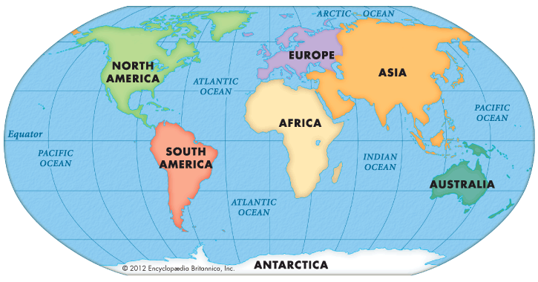

**Maps and atlases**

**Maps** are useful tools to help people find their way to and from somewhere. They are much easier to carry than a **globe** and much more detail can be added to them.

Maps can show the whole world, a single country or even a single town or village. Maps of different countries can be put together in a book called an **atlas** or they can be on a single sheet of paper. These can be useful to carry when you go walking so you do not get lost.

**Task 1: Memory Test**

*Instructions: Try to label the continents and oceans from memory;*

## *Outline map of the world*

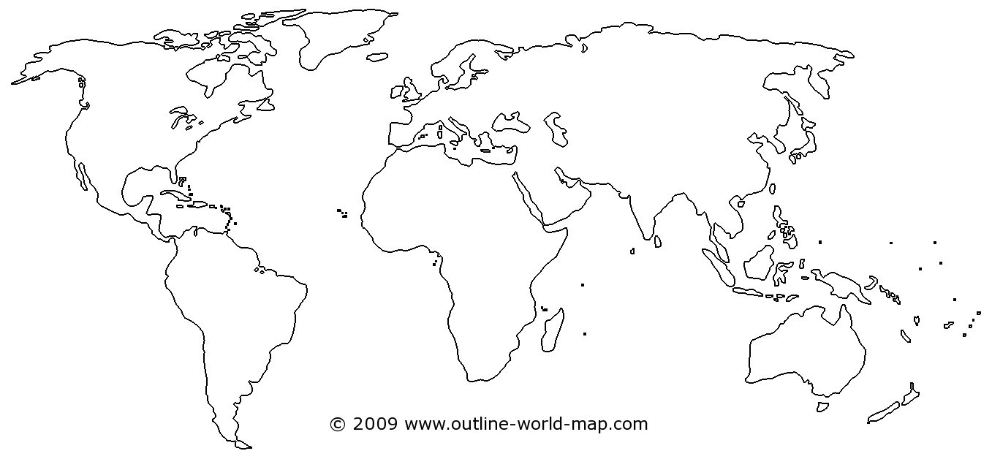

## What are latitude and longitude?

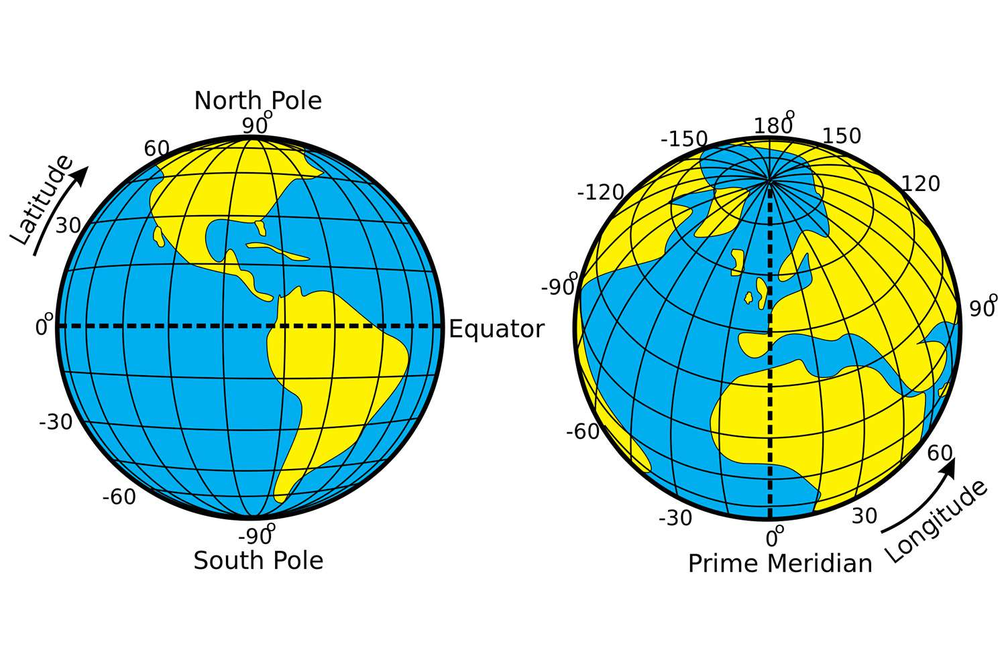To help locate where a place is in the world, people use imaginary lines:

* To find out how far **north** or **south** a place is, lines of **latitude** are used. These lines run parallel to the Equator.
* To find out how far **east** or **west** a place is, lines of **longitude** are used. These lines run from the top of the Earth to the bottom.

**Task 2:** Use the map to help you answer the questions

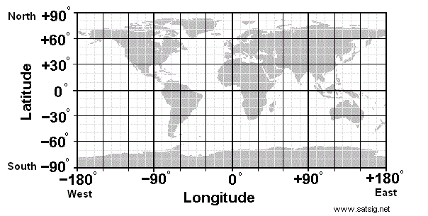**Section A**

Which CONTINENTS do these lines of latitude pass through?

1. 0o (Equator) ___________, ___________, ___________
2. 20oS ___________, ___________, ___________
3. 40oN ___________, ___________, ___________
4. 40oS ___________, ___________
5. 60oN ___________, ___________, ___________
6. 80oS _____________
7. 20oN ___________, ___________, ___________

**Section B**

Which CONTINENTS do these lines of longitude pass through?

1. 0o ___________, ___________, ___________
2. 60oE _____________, ____________
3. 120oE ____________, __________, __________
4. 60oW ___________, ___________, ___________
5. 100oE _______________, ___________
6. 120oW _____________, ______________
7. Which continent does ALL the lines of longitude pass through?_________________

## Hemispheres

The **Equator** is at the centre of the lines of latitude and is at 0° latitude. Anything lying south of the Equator is in the **Southern Hemisphere** and is labelled °S. Anything lying north of the Equator is in the **Northern Hemisphere** and is labelled °N. The North Pole is 90° N and the South Pole is 90° S.

The line labelled 0° longitude is called the **Prime Meridian** or the **Greenwich Meridian** and runs through London. Anything lying east of the Greenwich Meridian is in the **Eastern Hemisphere** and is labelled °E. Anything lying west of the Greenwich Meridian is in the **Western Hemisphere** and is labelled °W.

**What are time zones?**

**Time zones** are divided by imaginary lines called **meridians** which run from the North Pole to the South Pole. There is an imaginary line running through the UK called the **Prime Meridian**. It runs through a place in London called **Greenwich**. The Prime Meridian splits the world into eastern and western **hemispheres**.

Time in countries to the east of the Prime Meridian is always in front of that in the UK. Time in countries to the west of the Prime Meridian is always behind that of the UK.

**Time in different parts of the world**

As the Earth rotates on its **axis**, the Sun only shines on the side of the Earth that it is facing. This means:

* it is **daytime** for the parts of the Earth that have the Sun shining on them
* it is **night-time** for places that are on the opposite side of the Earth and are in the shade

As it is night in some parts of the world while it is day in other parts, different places in the world have different times. This is why the world is divided into **24 different time zones**. One for each hour in a day.Very large countries that are spread out across many time zones, such as Russia or the USA, are divided into separate time zones.

**Fast 5 Checkpoint 1: Answer the following questions;**

1. Name the 7 continents……………………………………………………………………….

…………………………………………………………………………………………………………...

1. Latitude is an imaginary line showing how far……………. Or ………………….. a place is.
2. Longitude is an imaginary line showing how far…………….. or …………….. a place is.
3. Time zones are divided by imaginary lines called…………………..
4. The line of longitude running along 0 is called the **…………………….**

## How to use a map

The top of most maps is **north** and a **compass** can be used to find which **direction** north is. Compasses show four directions - north, **east, south** and **west**.

The needle always points north, so when that is lined up with the map it is easy to see in which direction things are.

**Task 3: Compass points:**

1.Add North, East, South and West to the correct points on the 4 point compass.

2. Add North, South, East, West, North East, North West, South East and South West to the 8 point compass.

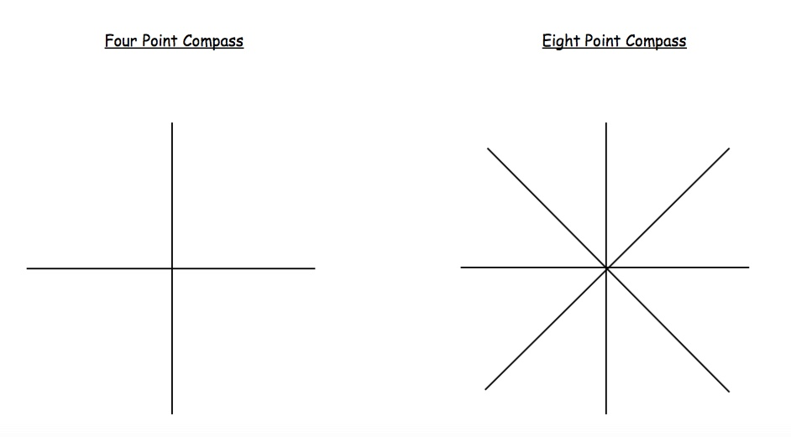

Maps are not drawn to the same size as the ground because they would be far too big! Instead they are drawn to a smaller **scale**.

The scale on a map is a set of numbers that can be used to compare distances and can be written, for example, as 1:25,000. This means that the actual size of the ground is 25,000 times bigger than it is on the map.  The same scale can also be written as 4cm to 1km, so every four centimeters on the map is one kilometre in real life.

**Task 4: Using Direction**

Follow the directions to find the key words:

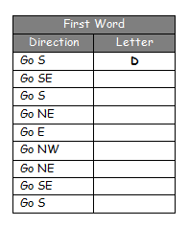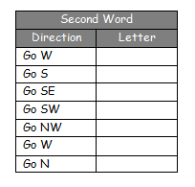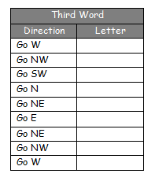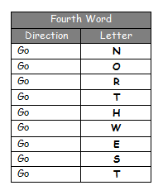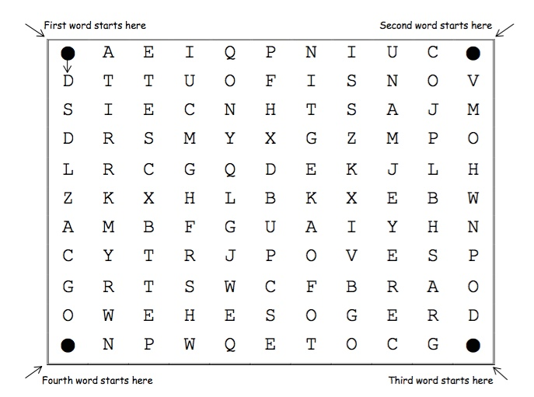

## Symbols

**Symbols** are generally the same on most types of map. For example, buildings or **tourist attractions** are shown with blue symbols. Different types of roads are shown in different colors - blue for a **motorway**, red for a **main road** and yellow or orange for **narrower roads**. Dotted green lines are usually used to show **footpaths**.

**Task 5**: Match the symbols to the correct description

|  |  |  |
| --- | --- | --- |
|  |  | *School* |
|  | *Place of worship* |
|  | *Parking* |
|  | *Railway Station* |
|  | *Campsite* |

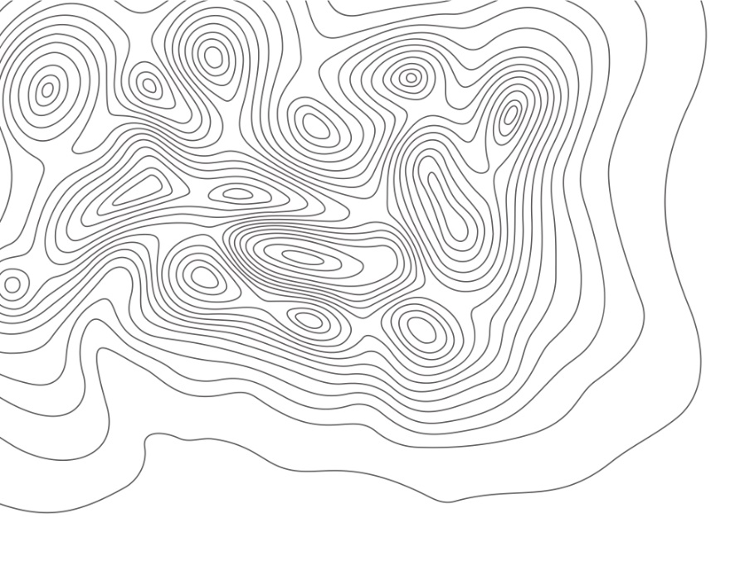**Contours**

Some maps, especially ones that people use to find their way around the countryside, contain brown **contour lines**. These are lines that show high and low areas of land.

The contour lines join up areas of the same height, and when they are close together it means the hill or mountain is **steep**. When they are far apart it means the land is gently sloping, or **undulating**.

**Grid References**

A grid of squares helps the map-reader to locate a place. The vertical lines are called **eastings**. They are numbered - the numbers increase to the east. The horizontal lines are called **northings** as the numbers increase in an northerly direction.

### Things to remember:

* When you give a grid reference, always give the easting first: "**Along the corridor and up the stairs**".

**Four-figure grid references** can be used to pinpoint a location to within a square. To find the number of the square:

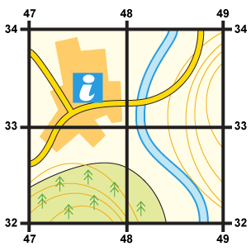

* Start at the left-hand side of the map and go east until you get to the bottom-left-hand corner of the square you want. Write this number down.
* Move north until you get to the bottom-left corner of the square you want. Look at the number of this grid line and add it to the two-digit number you already have.
* This is your four-figure grid reference.
* In this case, the tourist information office is in grid square 4733.

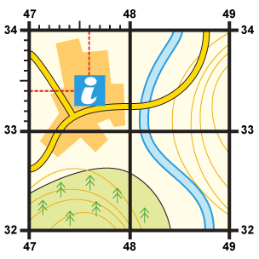Sometimes it is necessary to be even more accurate. In this case you can imagine that each grid is divided into 100 tiny squares. The distance between one grid line and the next is divided into tenths.

1. First, find the four-figure grid reference but leave a space after the first two digits.
2. Estimate or measure how many tenths across the grid square your symbol lies. Write this number after the first two digits.
3. Next, estimate how many tenths up the grid square your symbol lies. Write this number after the last two digits.
4. You now have a six figure grid reference. In this instance, the tourist information office is located at 476334.

**Task 6: Fill in the grid square of each letter below, one example is done for you.**

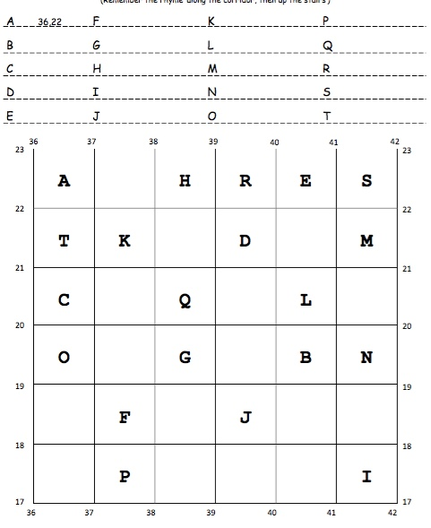

**Fast 5 Checkpoint 2: Answer the following questions;**

## Maps are not life sized, the are drawn to ………………………

## A red line on a map represents what? …………………………

## Contour lines show the …………………….. of the land

## When lines are close together this means land is …………………………

## When lines are far apart this means land is ………………………………

## The UK

## The United Kingdom is made up of 4 countries, England Scotland, Wales and Northern Ireland.

## Task 7: Label the 4 countries on the map;

## The Capital City of England is _______________________

## The Capital City of Scotland is _______________________

## The Capital City of Wales is _________________________

## The Capital City of Northern Ireland is _____________________

## Section 2: Places around the World

## Task 1: Label one country in each continent

## 

## Complete the table below for the UK, one country in Europe and one country in South America.

|  |  |  |  |  |
| --- | --- | --- | --- | --- |
| Country | Population | Flag | Capital City | Physical Features (e.g. famous mountains, rivers etc) |
| United Kingdom |  |  |  |  |
|  |  |  |  |  |
|  |  |  |  |  |