NAME: TARGET:
End of Year 8 Assessment

1) Who was Jairus? [1]
- A disciple of Jesus
- Someone who Jesus raised from the dead
- The father of a girl Jesus raised from the dead
- someone who disliked Jesus

2) What is the definition of Son of Man? [1]
…………………………………………………………………………………………………………………………………………………
…………………………………………………………………………………………………………………………………………………
…………………………………………………………………………………………………………………………………………………

3) What word describes "An acknowledgement or declaration of something" [1]
…………………………………………………………………………………………………………………………………………………
…………………………………………………………………………………………………………………………………………………
…………………………………………………………………………………………………………………………………………………

4) What word describes "The Old Testament prophet believed to return before the Messiah" [1]
- John the Baptist
- Jairus
- Moses
- Elijah

5) Messiah means: [1]
- God in the form of a human
- A type of person who wears special clothes
- The Anointed One (Christ) who would bring in God’s Kingdom
- The person the Jews would choose to lead them

6) Write three characteristics of the Messiah that the Jews were expecting [3]
…………………………………………………………………………………………………………………………………………………
…………………………………………………………………………………………………………………………………………………
…………………………………………………………………………………………………………………………………………………
…………………………………………………………………………………………………………………………………………………

Read the passage of Jesus' Baptism

2 It began as the prophet Isaiah had written:
“God said, ‘I will send my messenger ahead of you to open the way for you.’ 3 Someone is shouting in the desert, ‘Get the road ready for the Lord; make a straight path for him to travel!’”

4 So John appeared in the desert, baptizing and preaching. “Turn away from your sins and be baptized,” he told the people, “and God will forgive your sins.” 5 Many people from the province of Judea and the city of Jerusalem went out to hear John. They confessed their sins, and he baptized them in the Jordan River.

6 John wore clothes made of camel's hair, with a leather belt around his waist, and his food was locusts and wild honey. 7 He announced to the people, “The man who will come after me is much greater than I am. I am not good enough even to bend down and untie his sandals. 8 I baptize you with water, but he will baptize you with the Holy Spirit.”

9 Not long afterward Jesus came from Nazareth in the province of Galilee, and was baptized by John in the Jordan. 10 As soon as Jesus came up out of the water, he saw heaven opening and the Spirit coming down on him like a dove. 11 And a voice came from heaven, “You are my own dear Son. I am pleased with you.”

7) Jesus' purpose is to save people from their sin is shown by the phrase... [1]
- "Get the road ready for the Lord"
- "Turn away from your sins"
- "he will baptize you with the Holy Spirit"
- "The man who will come after me is much greater than I am"

8) This is a completion of a prophecy which shows that Jesus is the Messiah is shown by the phrase ... [1]
- "the Spirit coming down on him like a dove"
- "It began as the prophet Isaiah had written"
- "he baptized them in the Jordan River"
- "Not long afterward Jesus came from Nazareth in the province of Galilee"

9) Why is water an important feature of Baptism? [2]
…………………………………………………………………………………………………………………………………………………
…………………………………………………………………………………………………………………………………………………
…………………………………………………………………………………………………………………………………………………
…………………………………………………………………………………………………………………………………………………
…………………………………………………………………………………………………………………………………………………
…………………………………………………………………………………………………………………………………………………
…………………………………………………………………………………………………………………………………………………
…………………………………………………………………………………………………………………………………………………

10) Explain what this tells us about the Trinity (God as Father, Spirit, Son) [2]
…………………………………………………………………………………………………………………………………………………
…………………………………………………………………………………………………………………………………………………
…………………………………………………………………………………………………………………………………………………
…………………………………………………………………………………………………………………………………………………
…………………………………………………………………………………………………………………………………………………
…………………………………………………………………………………………………………………………………………………
…………………………………………………………………………………………………………………………………………………
…………………………………………………………………………………………………………………………………………………
11) Describe the story that is shown in this image [3]
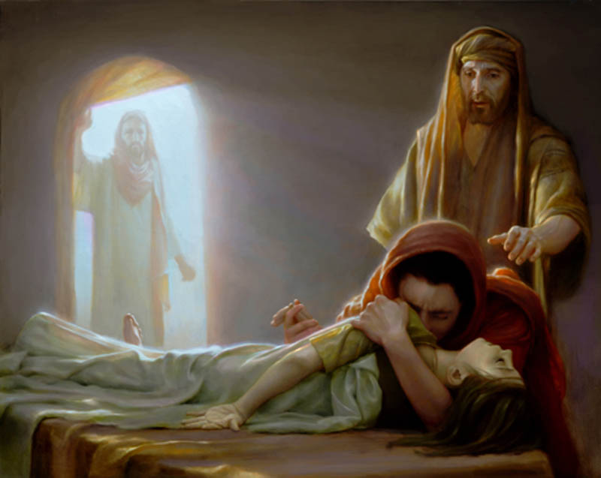

…………………………………………………………………………………………………………………………………………………
…………………………………………………………………………………………………………………………………………………
…………………………………………………………………………………………………………………………………………………
…………………………………………………………………………………………………………………………………………………
…………………………………………………………………………………………………………………………………………………
…………………………………………………………………………………………………………………………………………………
…………………………………………………………………………………………………………………………………………………
…………………………………………………………………………………………………………………………………………………
…………………………………………………………………………………………………………………………………………………
…………………………………………………………………………………………………………………………………………………
…………………………………………………………………………………………………………………………………………………
…………………………………………………………………………………………………………………………………………………
12) Put the events of the Transfiguration in the correct order [3]

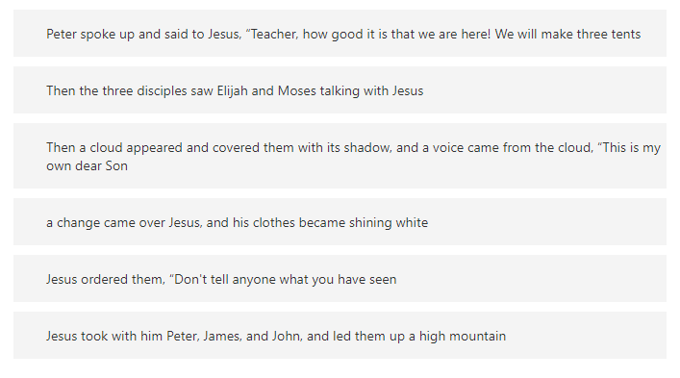
13) Select for each of these statements on the left, choose the evidence that it MOST applies to [5]
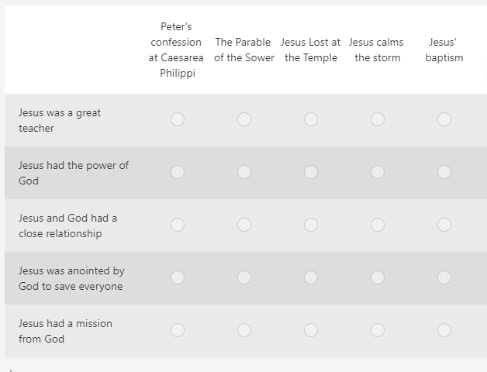
14) To what extent do you think these examples from Jesus' life show he was the Messiah?

1 | 2 | 3 | 4 | 5 | 6 | 7 | 8 | 9 | 10
Not at all Strongly

15) Use your answers to questions 13 and 14 to discuss whether Jesus shows that he is the Messiah.
[This will be marked out of 15]
…………………………………………………………………………………………………………………………………………………
…………………………………………………………………………………………………………………………………………………
…………………………………………………………………………………………………………………………………………………
…………………………………………………………………………………………………………………………………………………
…………………………………………………………………………………………………………………………………………………
…………………………………………………………………………………………………………………………………………………
…………………………………………………………………………………………………………………………………………………
…………………………………………………………………………………………………………………………………………………
…………………………………………………………………………………………………………………………………………………
…………………………………………………………………………………………………………………………………………………
…………………………………………………………………………………………………………………………………………………
…………………………………………………………………………………………………………………………………………………
…………………………………………………………………………………………………………………………………………………
…………………………………………………………………………………………………………………………………………………
…………………………………………………………………………………………………………………………………………………
…………………………………………………………………………………………………………………………………………………
…………………………………………………………………………………………………………………………………………………
…………………………………………………………………………………………………………………………………………………
…………………………………………………………………………………………………………………………………………………
…………………………………………………………………………………………………………………………………………………
…………………………………………………………………………………………………………………………………………………
…………………………………………………………………………………………………………………………………………………
…………………………………………………………………………………………………………………………………………………
…………………………………………………………………………………………………………………………………………………
…………………………………………………………………………………………………………………………………………………
…………………………………………………………………………………………………………………………………………………
…………………………………………………………………………………………………………………………………………………
…………………………………………………………………………………………………………………………………………………
…………………………………………………………………………………………………………………………………………………
…………………………………………………………………………………………………………………………………………………
…………………………………………………………………………………………………………………………………………………
…………………………………………………………………………………………………………………………………………………
…………………………………………………………………………………………………………………………………………………
…………………………………………………………………………………………………………………………………………………
…………………………………………………………………………………………………………………………………………………
…………………………………………………………………………………………………………………………………………………
…………………………………………………………………………………………………………………………………………………
…………………………………………………………………………………………………………………………………………………
……………………………………………………………………………………………………………………………………………
…………………………………………………………………………………………………………………………………………………
…………………………………………………………………………………………………………………………………………………
…………………………………………………………………………………………………………………………………………………
…………………………………………………………………………………………………………………………………………………
…………………………………………………………………………………………………………………………………………………
…………………………………………………………………………………………………………………………………………………
…………………………………………………………………………………………………………………………………………………
…………………………………………………………………………………………………………………………………………………
…………………………………………………………………………………………………………………………………………………
…………………………………………………………………………………………………………………………………………………

